**Practical No. 4**

**Write a PHP program for creating and manipulating-**

**a. Indexed Array**

**b. Associative Array**

**c. Multidimensional Array**

**Code (Pg no. 6):**

<?php

    $course[0] = "Computer Engg.";

    $course[1] = "Information Tech.";

    $course[2] = "Electronics and Telecomm.";

    echo $course[2], "<br>";

    echo $course[0], "<br>";

    echo $course[1], "<br>";

?>

**Output:**

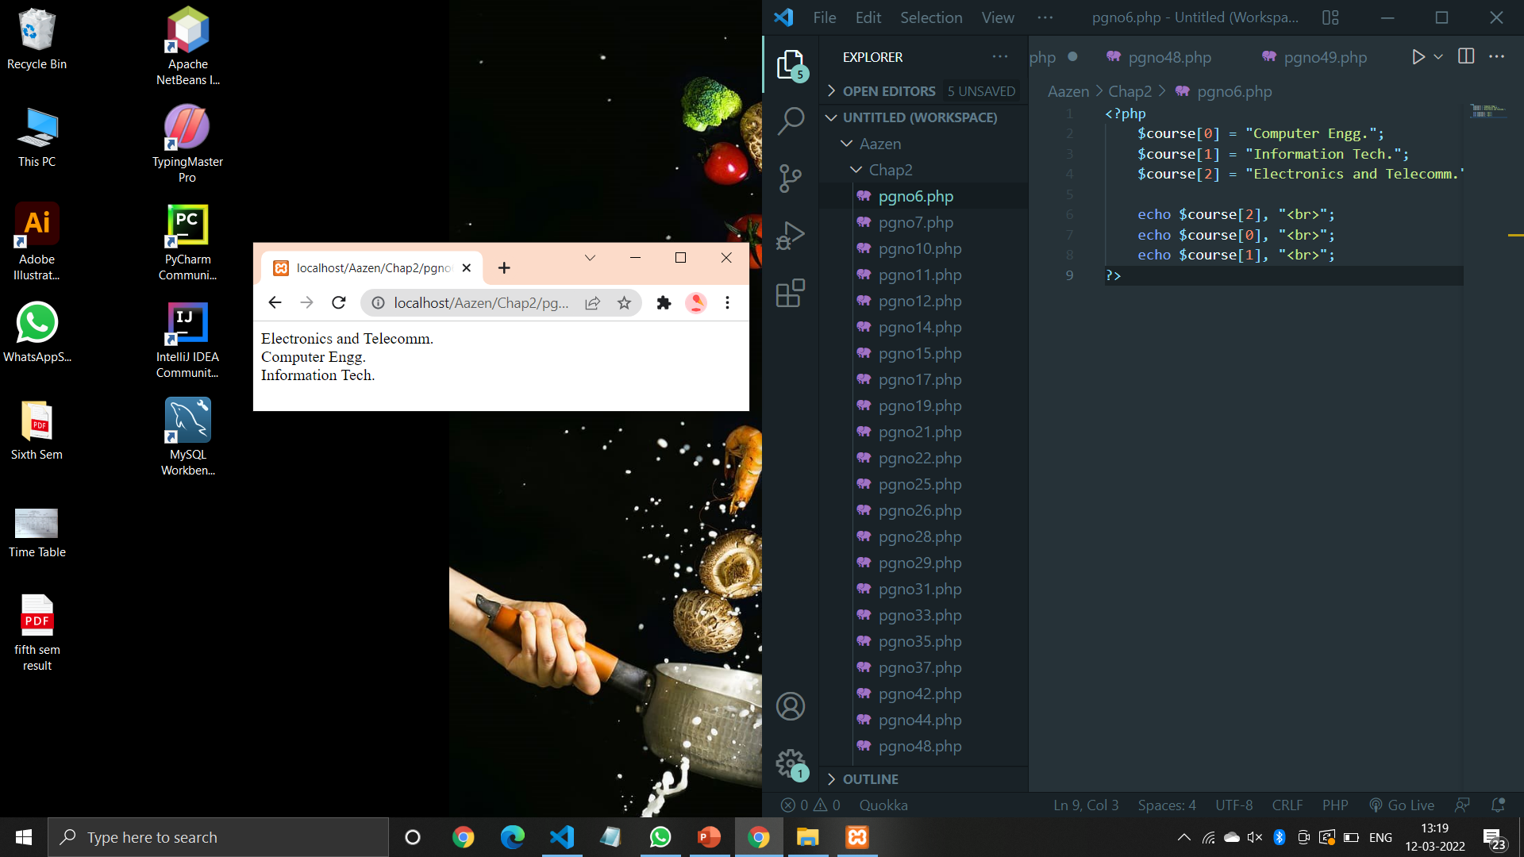

**Code (Pg no. 7):**

<?php

    $course = array(0 => "Computer Engg.",1=> "Information Tech.", 2=> "Electronics & Telecomm.");

    echo $course[1];

?>

**Output:**

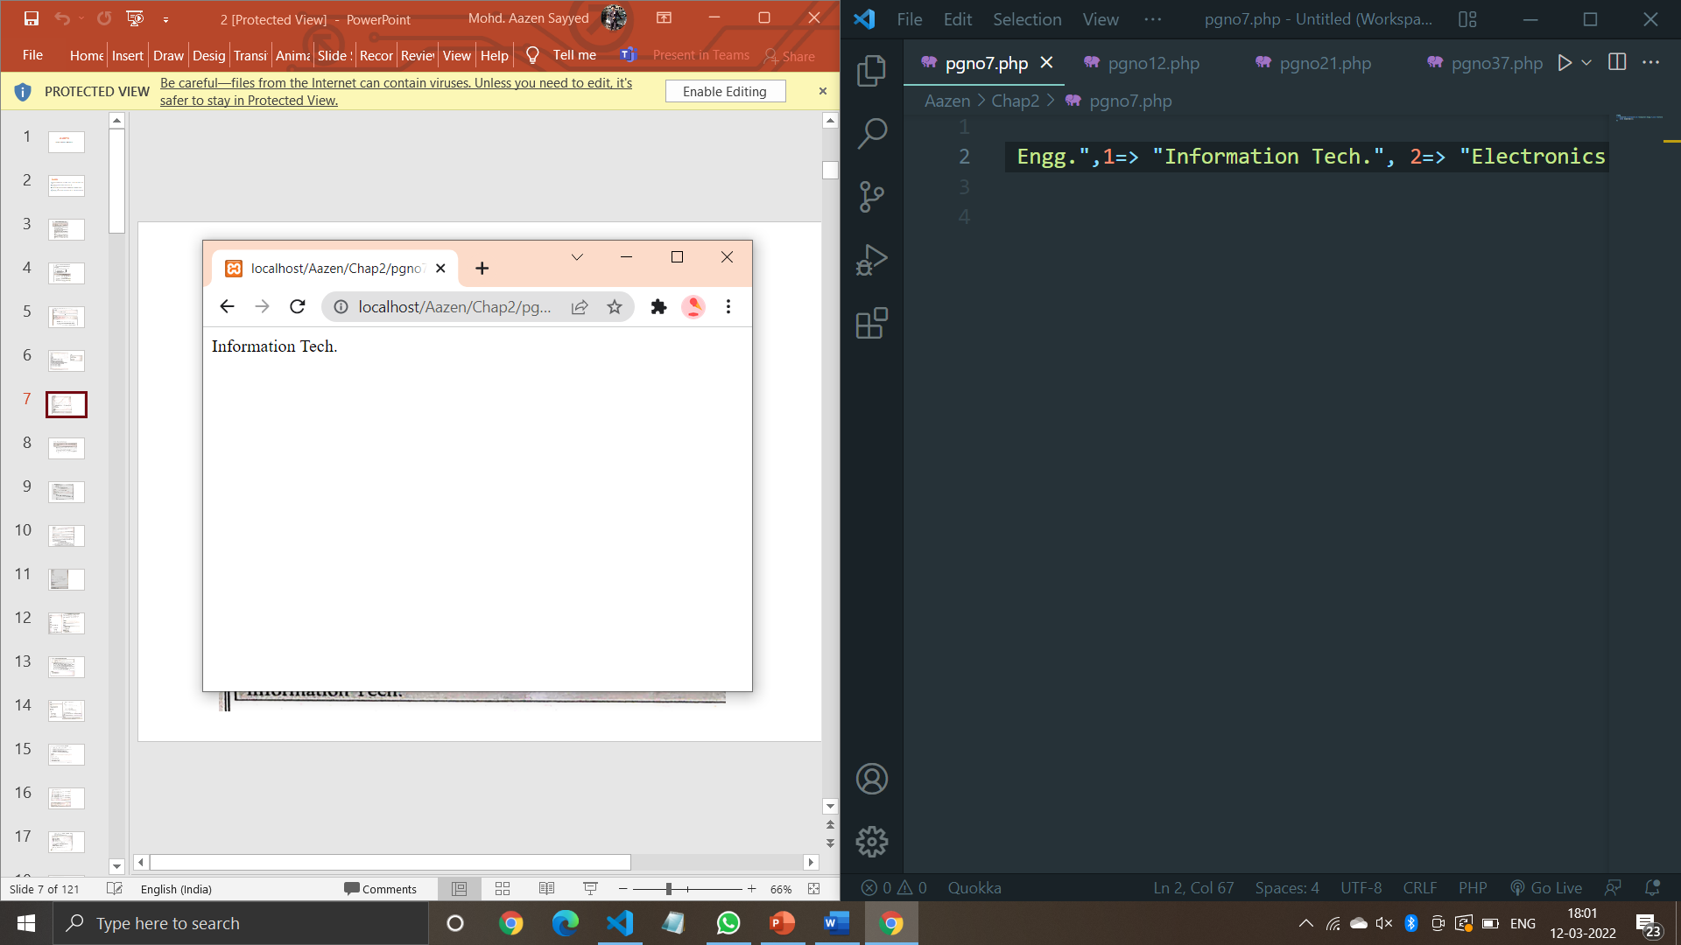

**Code (Pg no. 10):**

<?php

    $capital = array("Mumbai" => "Maharashtra", "Goa" => "Panaji", "Bihar" => "Patna");

    print_r($capital);

    echo "<br>";

    echo "Mumbai is a capital of ".$capital ["Mumbai"];

    ?>

**Output:**

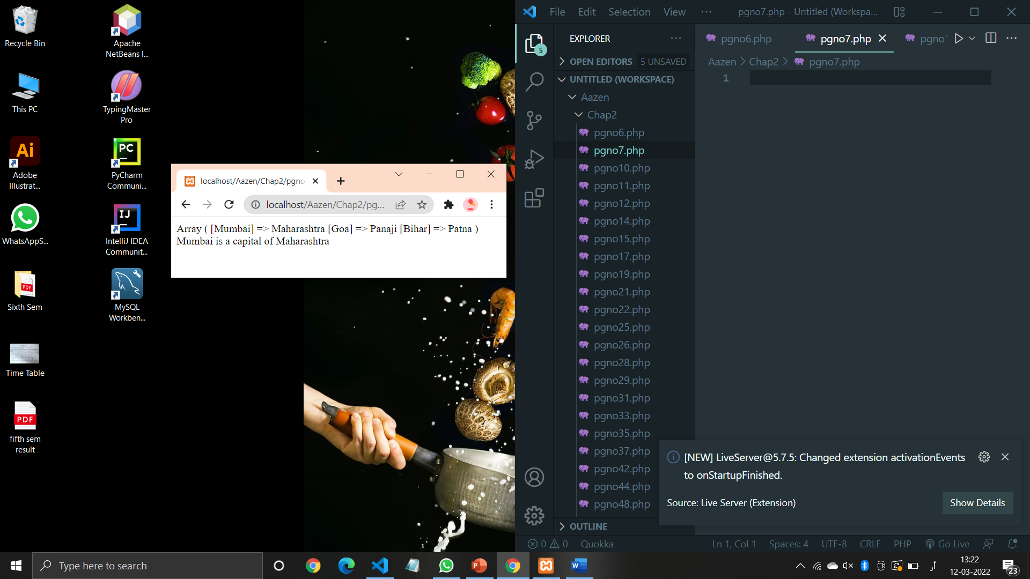

**Code (Pg no. 11):**

<?php

    $course = array(

        1 => "Computer Engg.",

        5 => "Information Tech.",

        3 => "Electronics and Telecomm."

    );

    echo $course[5];

    ?>

**Output:**

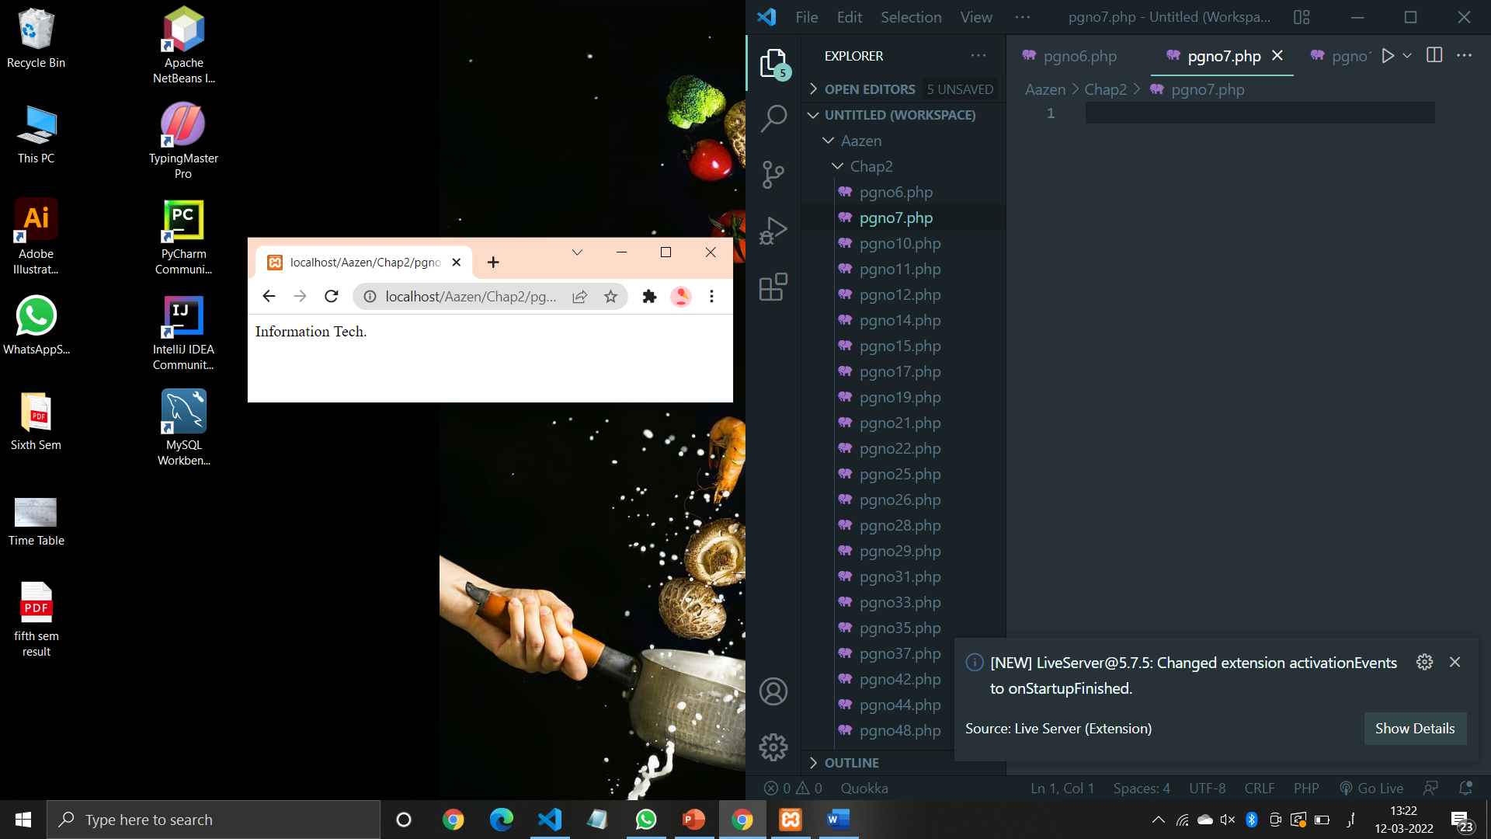

**Code (Pg no. 12):**

<?php

$course = array("CO"=>549,"IF"=>450,"EJ"=>100);

echo "course['CO']=",$course["CO"],"<br>";

echo "course['IF']=",$course["IF"],"<br>";

echo "course['EJ']=",$course["EJ"],"<br>";

?>

**Output:**

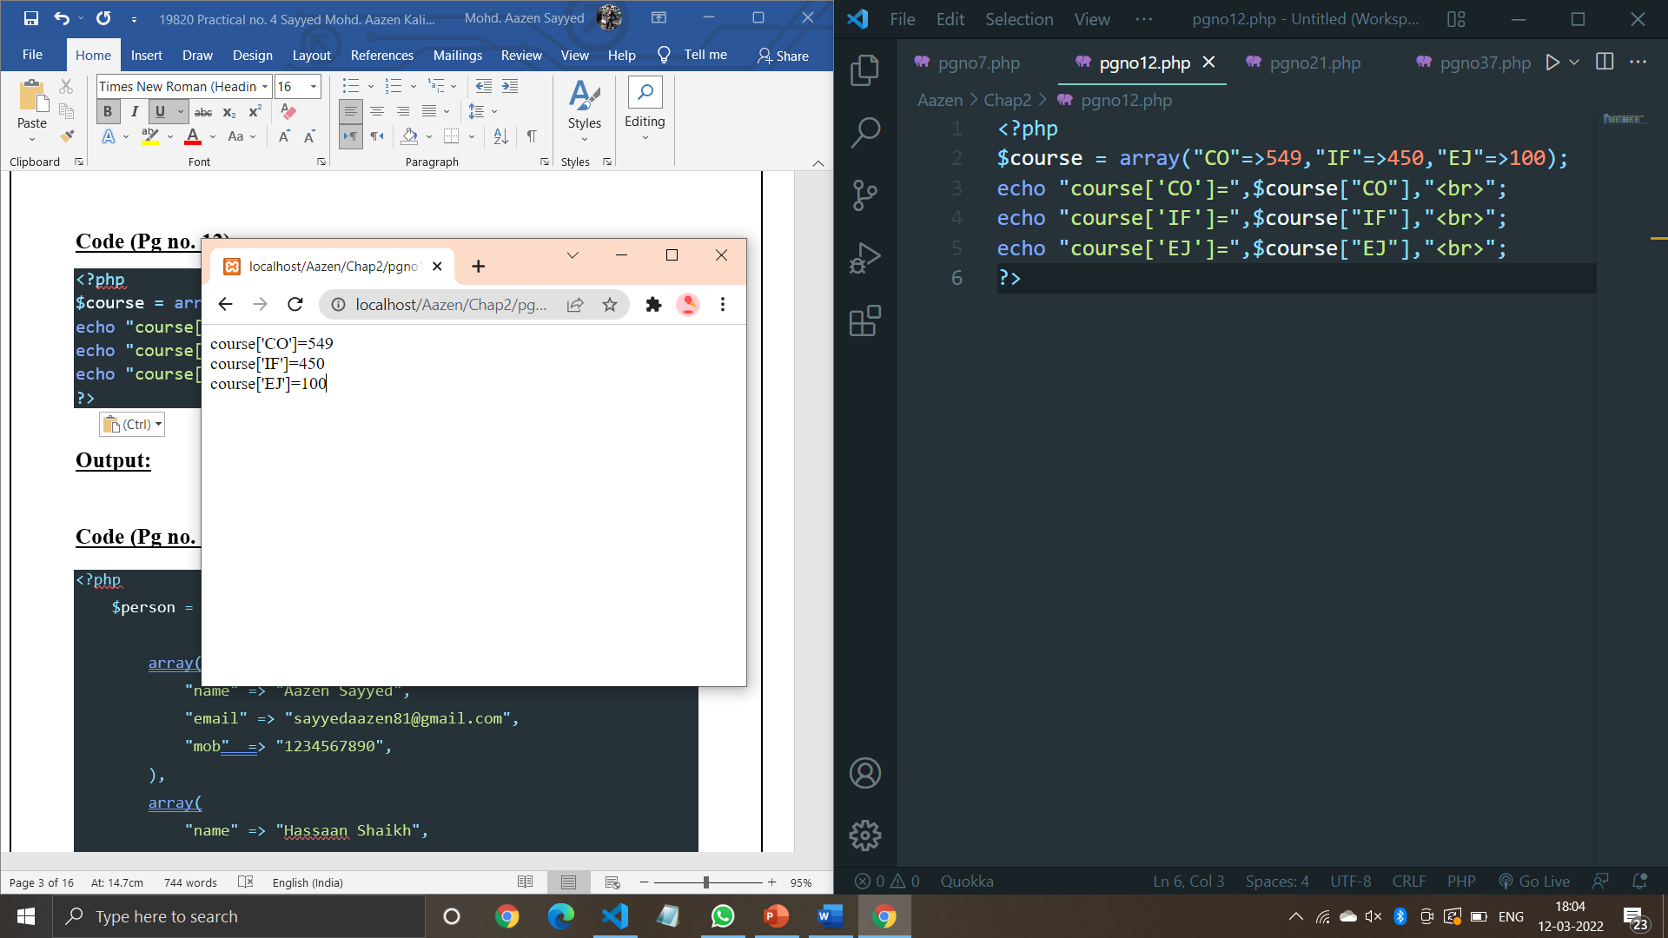

**Code (Pg no. 14):**

<?php

    $person = array(

        array(

            "name" => "Aazen Sayyed",

            "email" => "sayyedaazen81@gmail.com",

            "mob"  => "1234567890",

        ),

        array(

            "name" => "Hassaan Shaikh",

            "mob"  => "1234567890",

            "email" => "hassanShaikh@gmail.com"

        ),

        array(

            "name" => "Vinayak Sawant",

            "mob"  => "9137234878",

            "email" => "vinayaksawant859@gmail.com"

        )

        );

        echo "Aazen Sayyed's email-id is: ".$person[0]["email"],"<br>";

        echo "Vinayak Sawant's mobile no. is: ".$person[1]["mob"],"<br>";

    ?>

**Output:**

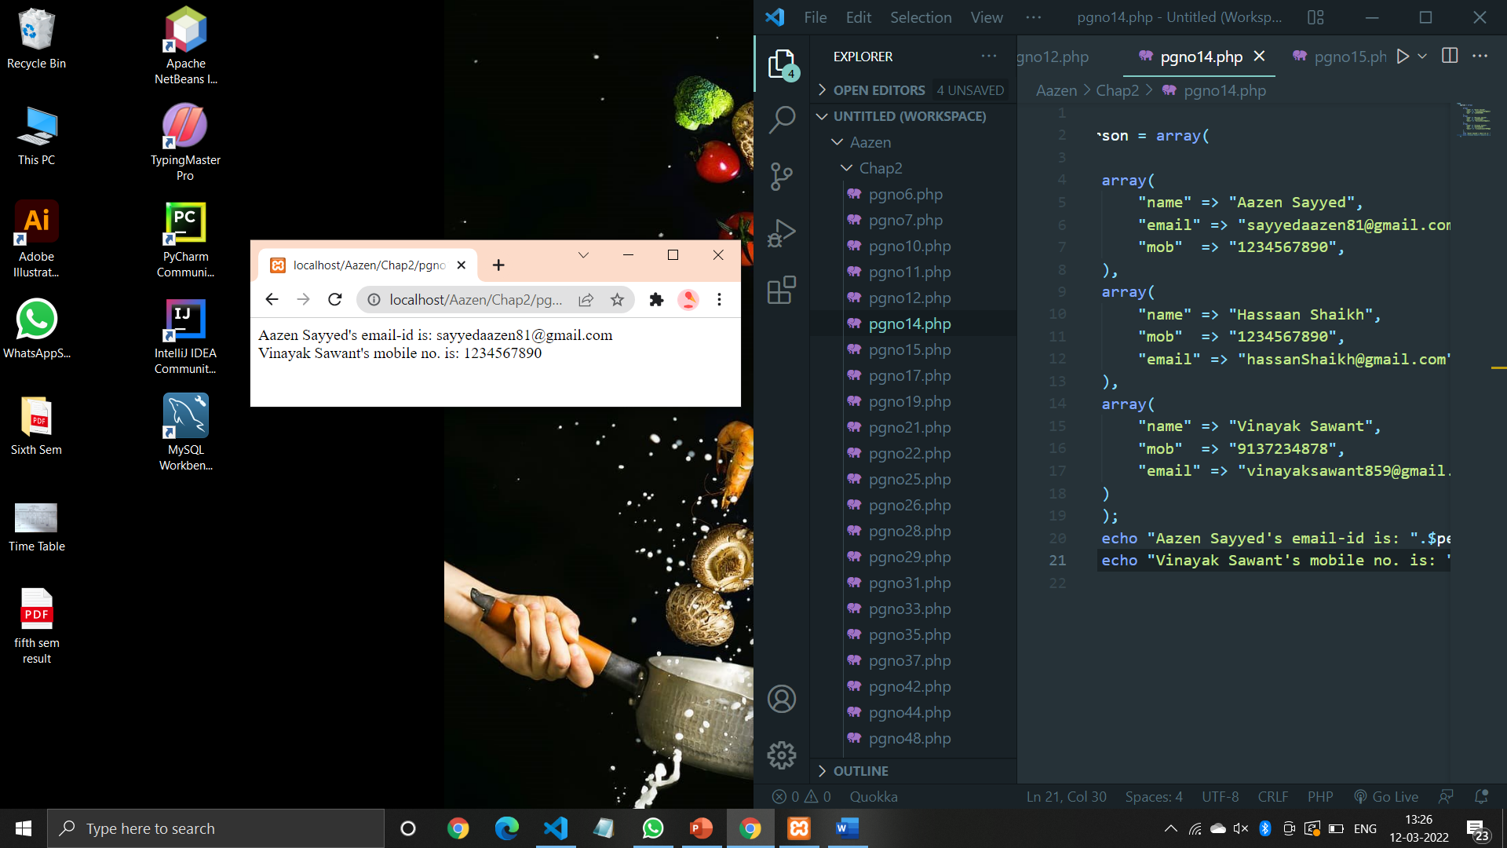

**Code (Pg no. 15):**

<?php

    $mobile = array

    (

        array("LG",20,18),

        array("Sony",30,13),

        array("Redmi",10,2),

        array("Samsung",40,15),

    );

    echo $mobile[0][0].": In Stock: ",$mobile[0][1].", sold: ".$mobile[0][2].".<br>";

    echo $mobile[1][0].": In Stock: ",$mobile[1][1].", sold: ".$mobile[1][2].".<br>";

    echo $mobile[2][0].": In Stock: ",$mobile[2][1].", sold: ".$mobile[2][2].".<br>";

    echo $mobile[3][0].": In Stock: ",$mobile[3][1].", sold: ".$mobile[3][2].".<br>";

    ?>

**Output:**

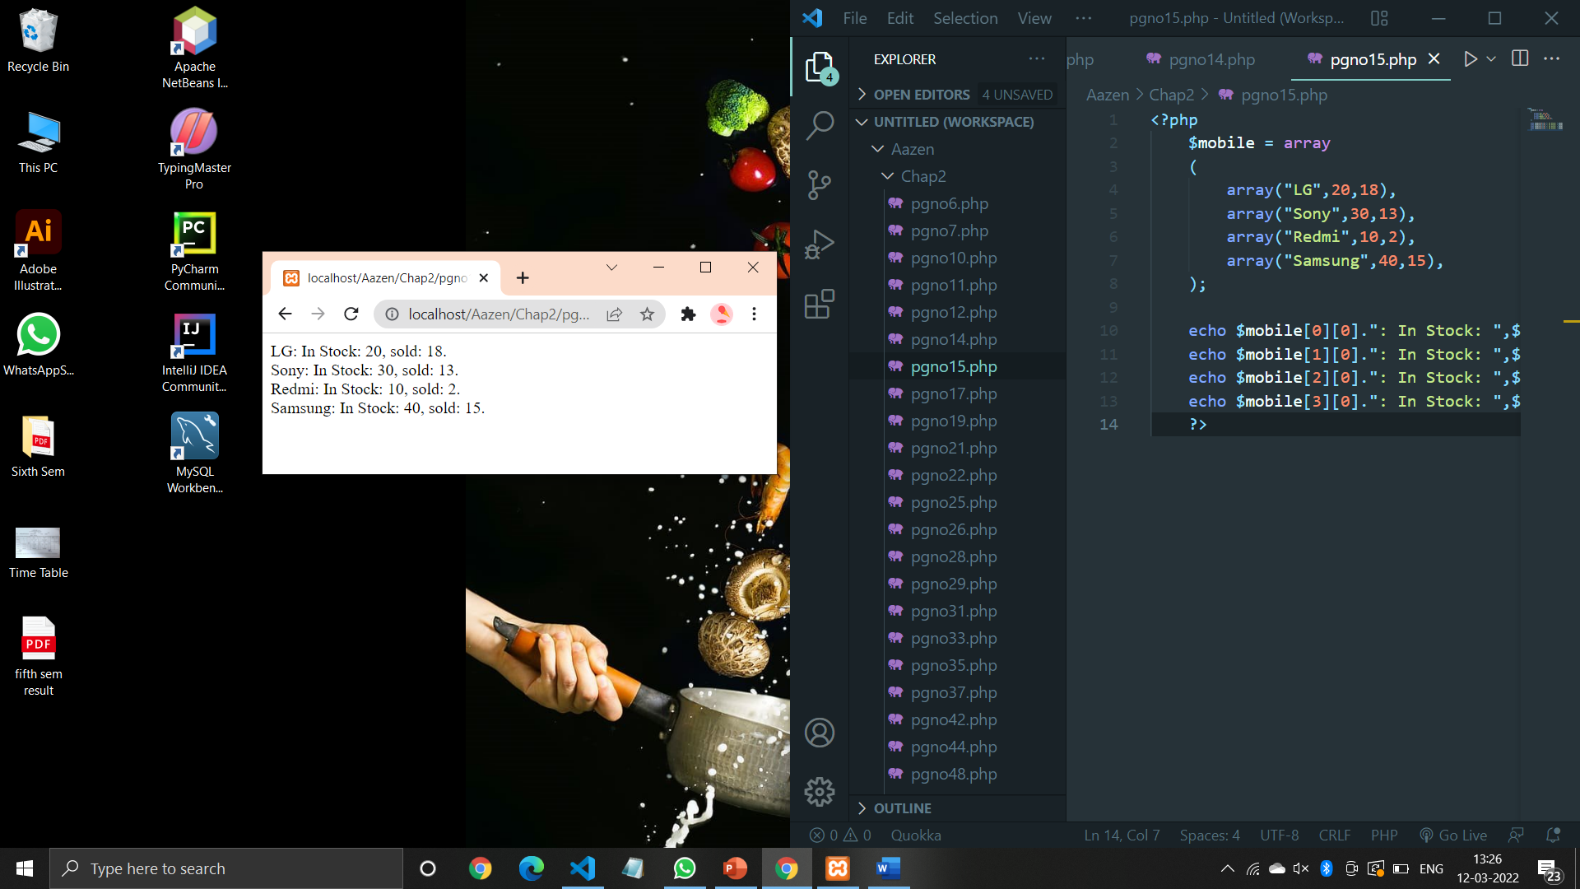

**Code (Pg no. 17):**

<?php

    $mobile = array

    (

        array("LG",20,18),

        array("Sony",30,13),

        array("Redmi",10,2),

        array("Samsung",40,15),

    );

*for* ($row=0; $row < 4; $row++)

    {

        echo "<p><b>Row Number $row</b></p>";

        echo "<ul>";

*for* ($col=0; $col < 3 ; $col++) {

            echo "<li>".$mobile[$row][$col]."</li>";

        }

        echo "</ul>";

    }

    ?>

**Output:**

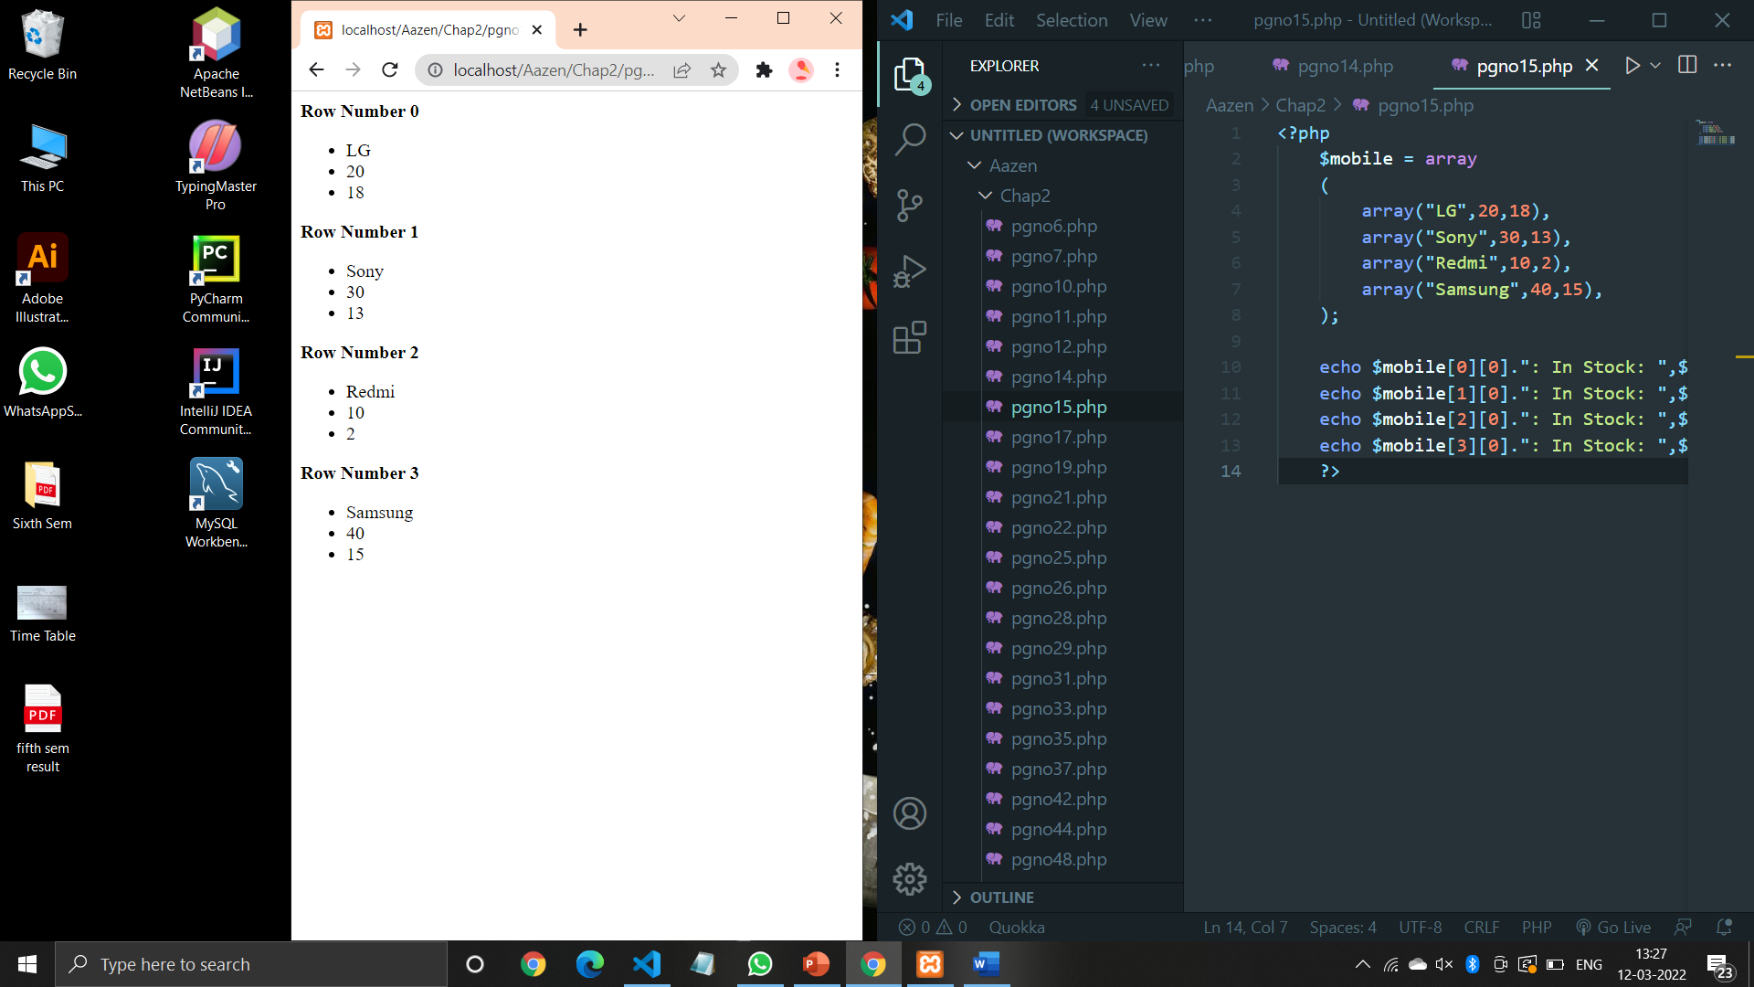

**Code (Pg no. 19):**

<?php

    $course["CO"]="Computer Engg.";

    $course["IF"]="Information Tech.";

    $course["EJ"]="Electronics and Telecomm.";

    extract($course);

    echo"CO=$CO<br>";

    echo"IF=$IF<br>";

    echo"EJ=$EJ<br>";

    ?>

**Output:**

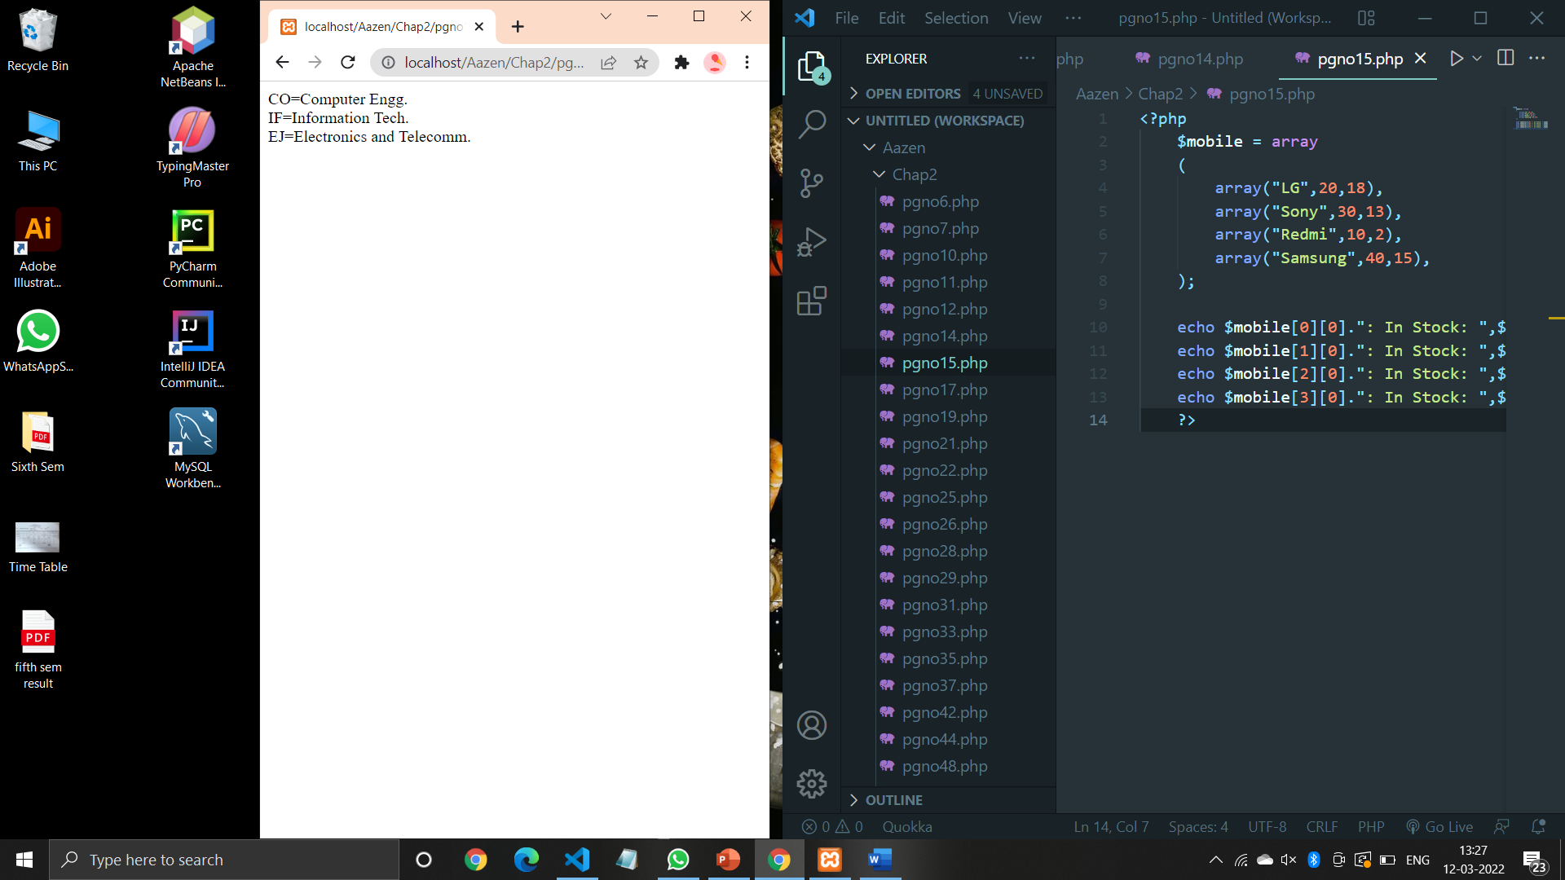

**Code (Pg no. 21):**

<?php

"<h3>Extracting variables from array</h3>"

$course[0]="Computer Engg";

$course[1]="Information Tech";

$course[2]="Electronics and Telecomm";

list($one,$two)=$course;

echo $one,"<br>";

echo $two;

?>

**Output:**

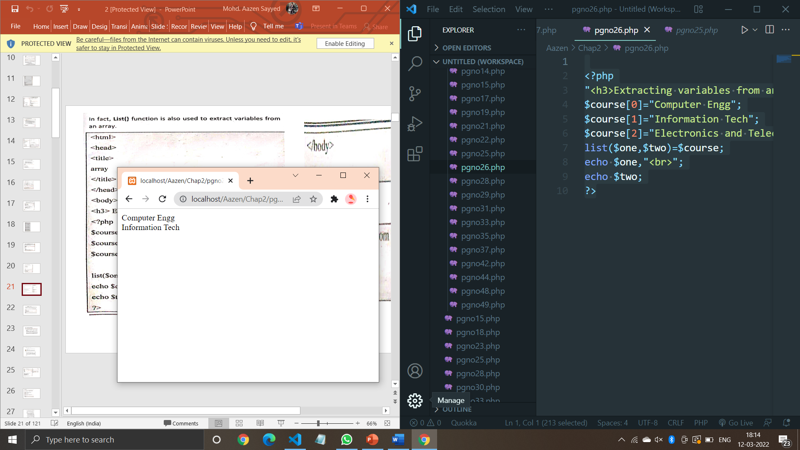

**Code (Pg no. 22):**

<?php

    $var1 = "PHP";

    $var2 = "JAVA";

    $var3 = compact("var1","var2");

    echo "Hii<br>";

    print_r($var3);

    ?>

**Output:**

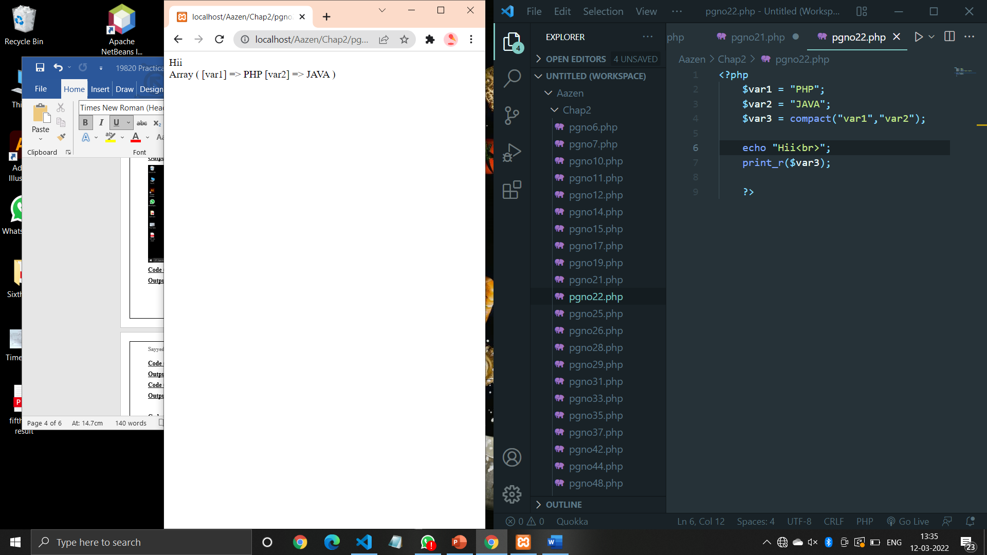

**Code (Pg no. 25):**

<?php

    $course[0]="Computer Engg";

    $course[1]="Information Tech";

    $course[2]="Electronics and Telecomm";

    $text = implode(",",$course);

    echo $text;

    ?>

**Output:**

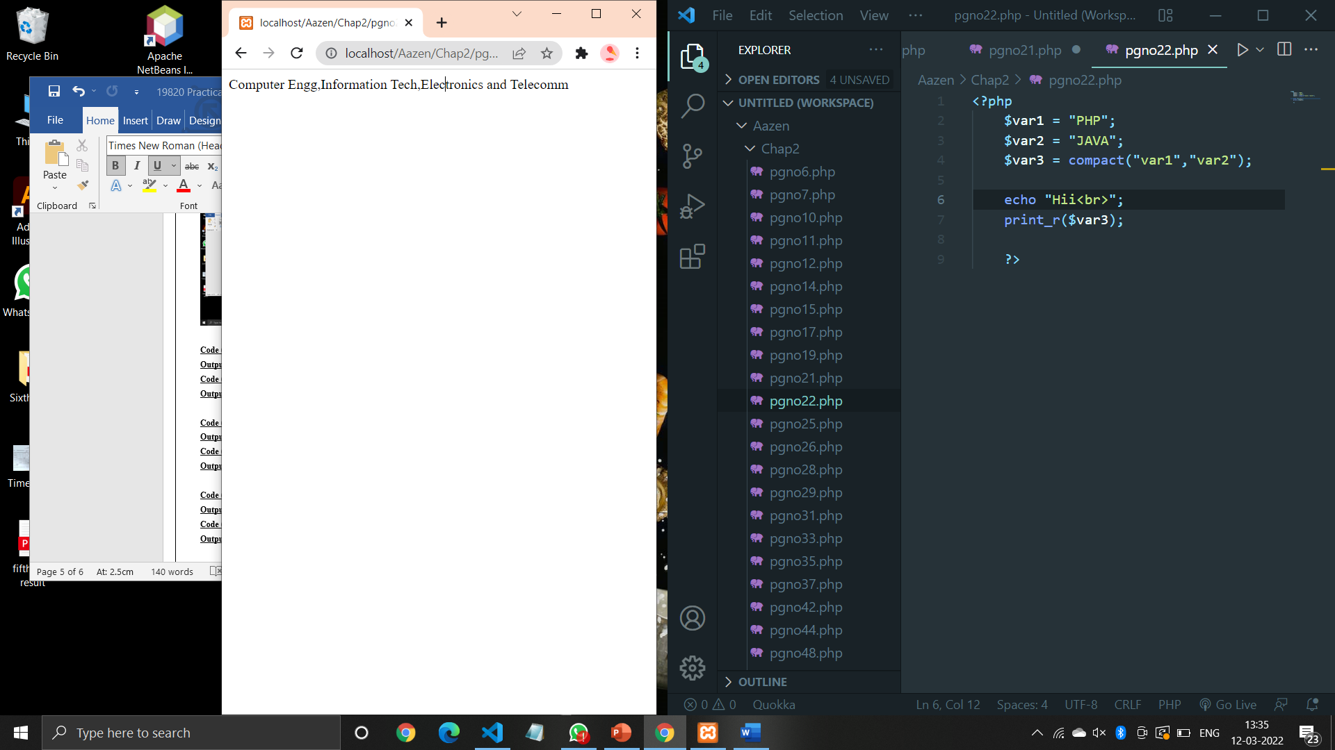

**Code (Pg no. 26):**

<?php

$InputArray = array('CO','IF','EJ');

print_r(implode($InputArray));

print_r("<br>");

print_r(implode("-",$InputArray));

?>

**Output:**

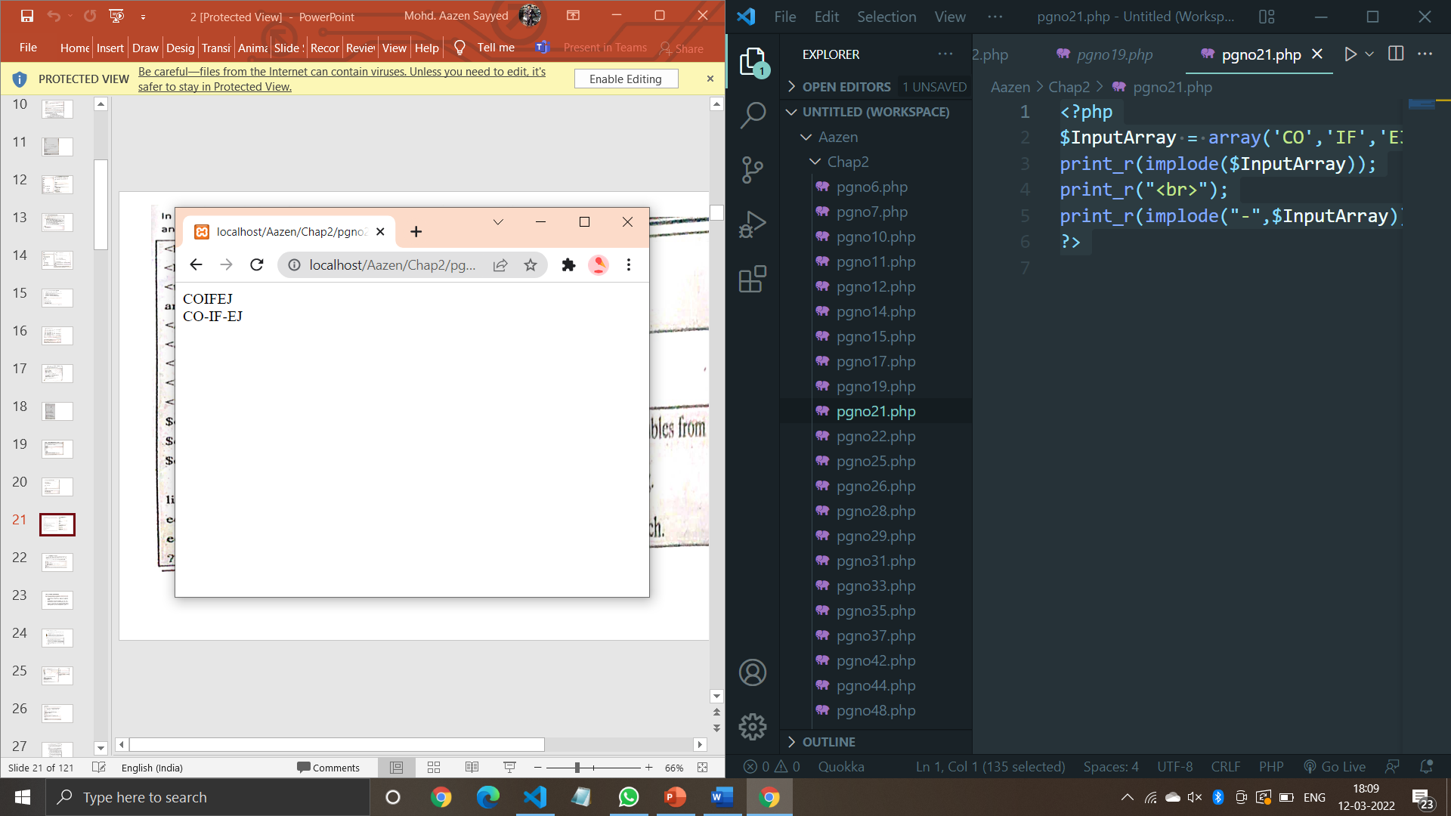

**Code (Pg no. 28):**

<?php

$str = "PHP: Welcome to the world of PHP";

print_r(explode(" ",$str));

        ?>

**Output:**

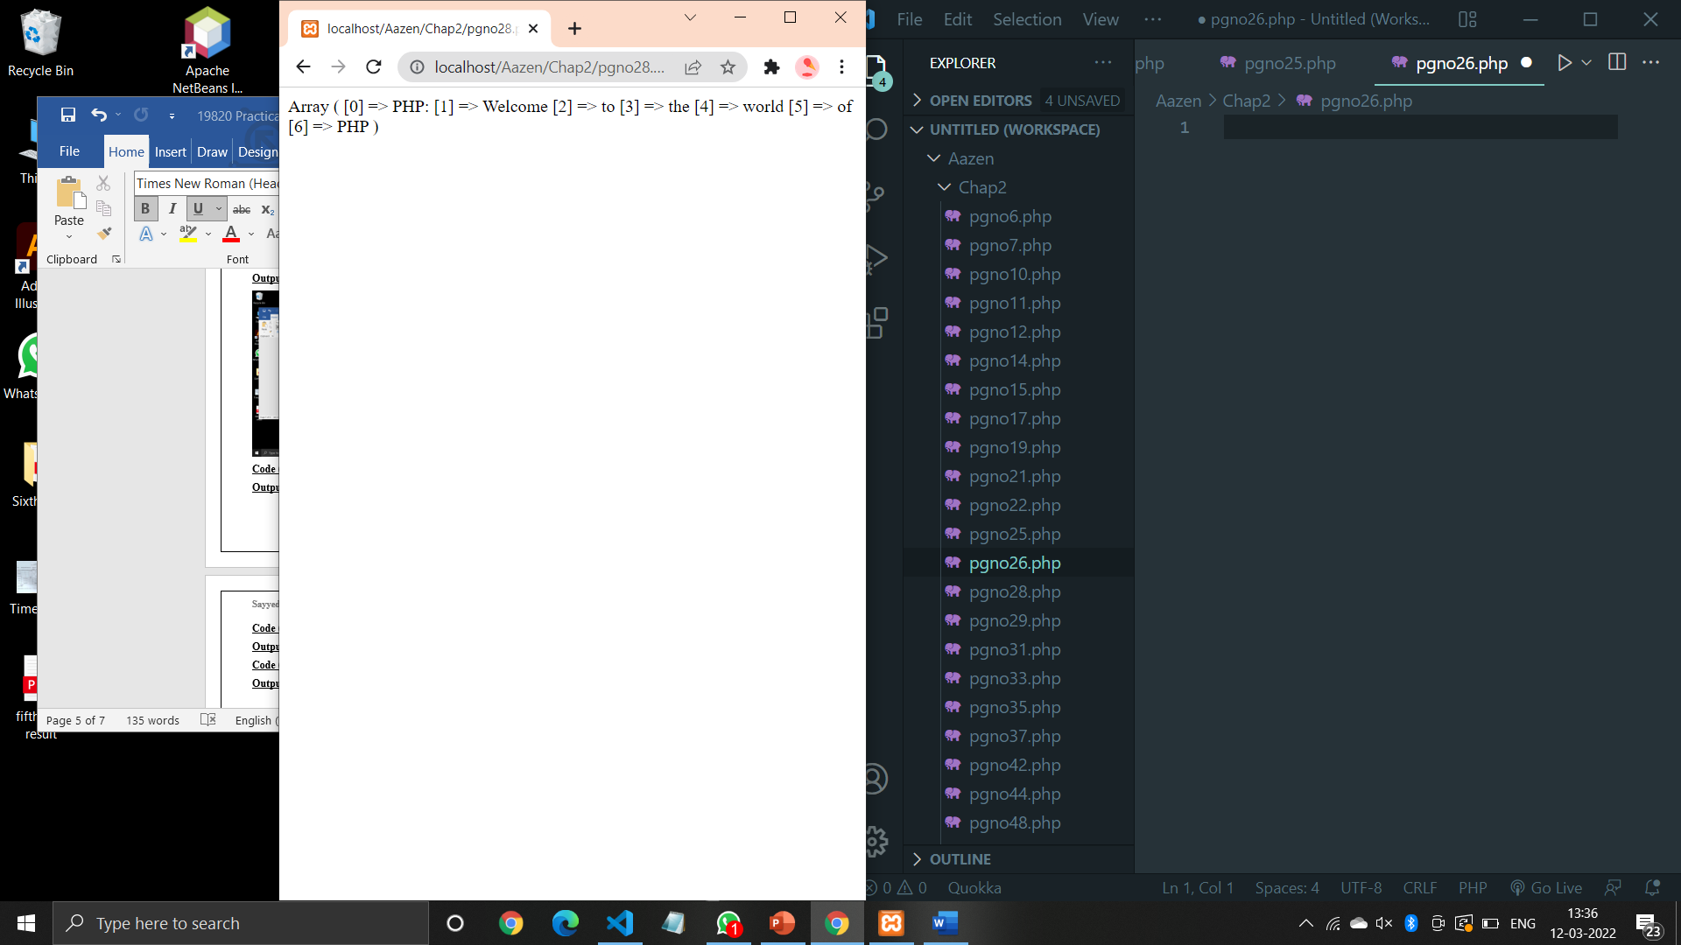

**Code (Pg no. 29):**

<?php

    $al = array("CO"=>"Computer Engg.","IF"=>"Information Tech.","EJ"=>"Electronics and Telecomm.");

    $result = array_flip($al);

    print_r($result);

    ?>

**Output:**

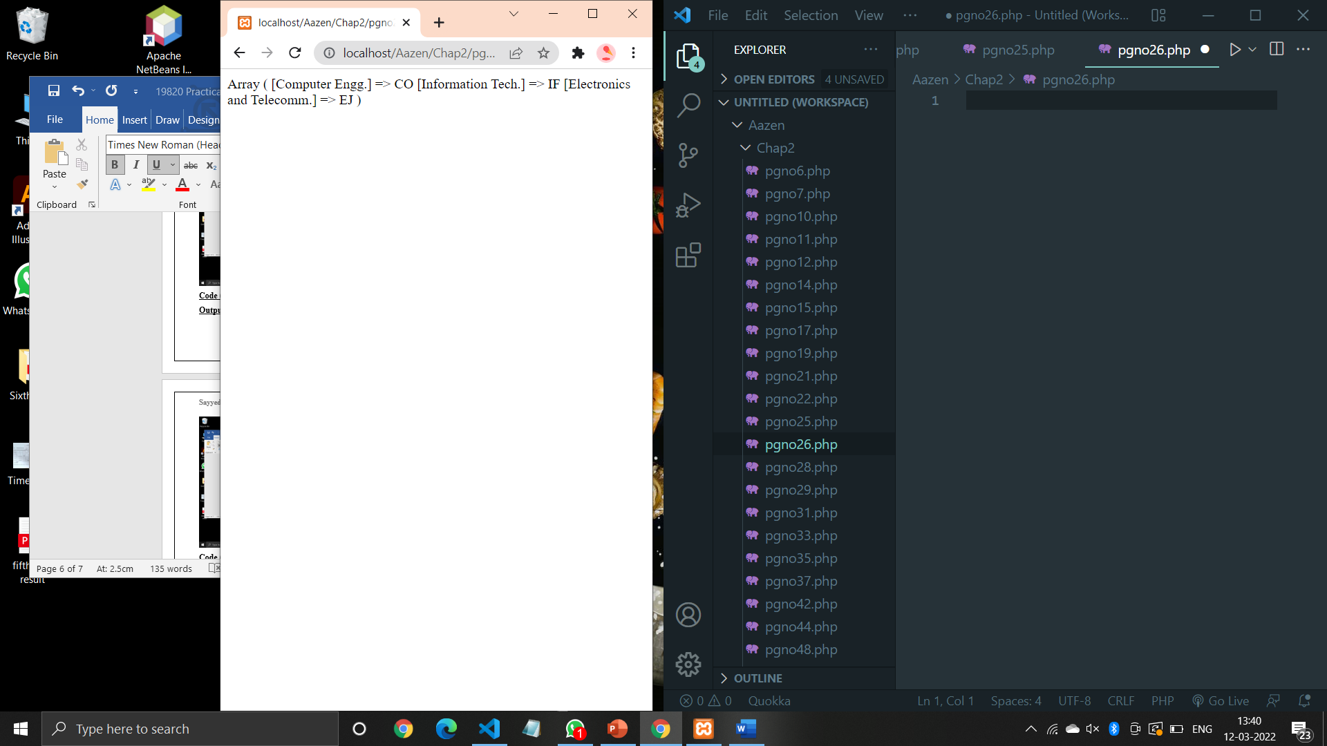

**Code (Pg no. 31):**

<?php

    $course = array("CO","IF", "EJ", "ME", "CE");

    echo "Looping using foreach: <br>";

*foreach* ($course as $val){

        echo $val. "<br>";

    }

*/* count() function is used to count the number of elements in an array */*

    $total = count($course);

    echo "<br> The number of elements are $total <br>";

*/* Another way to loop through the array using for */*

    echo "Looping using for: <br>";

*for* ($n=0; $n < $total ; $n++) {

        echo $course[$n], "<br>";

    }

    ?>

**Output:**

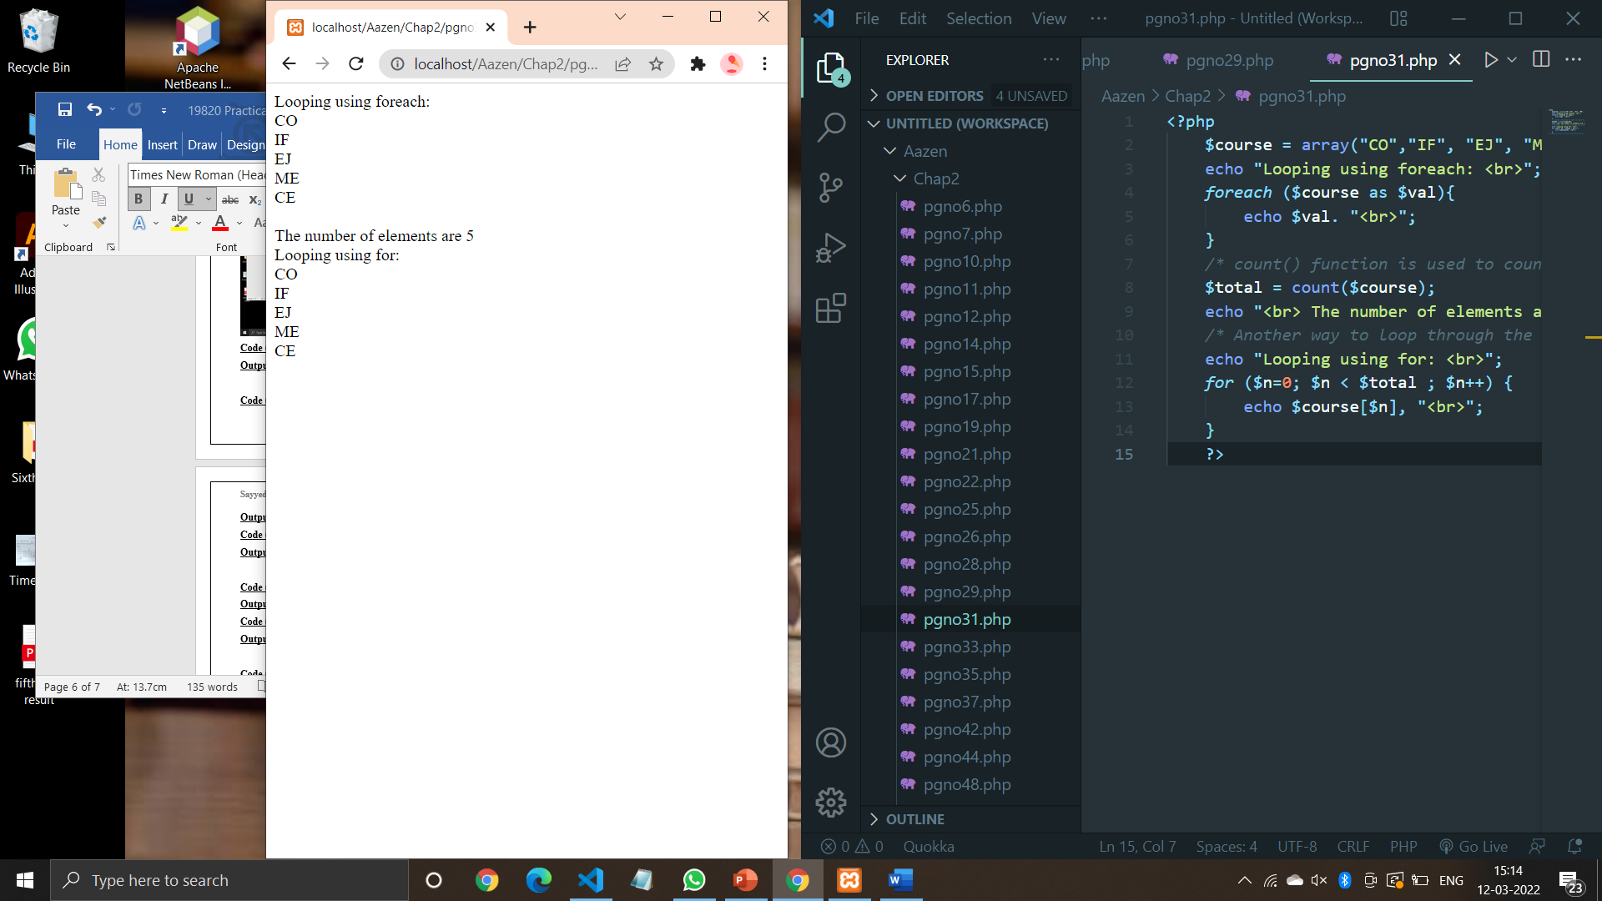

**Code (Pg no. 33):**

<?php

    $course[0]="Computer Engg";

    $course[1]="Information Tech";

    $course[2]="Electronics and Telecomm";

    echo "<h3>Before modification: </h3>";

    echo $course[0], "<br>";

    echo $course[1], "<br>";

    echo $course[2], "<br>";

    echo "<h3>After modification: </h3>";

    $course[2] = "Mechanical Engg.";

    $course[3] = "Civil Engg.";

*for* ($i=0; $i < count($course) ; $i++) {

        echo $course[$i], "<br>";

    }

    ?>

**Output:**

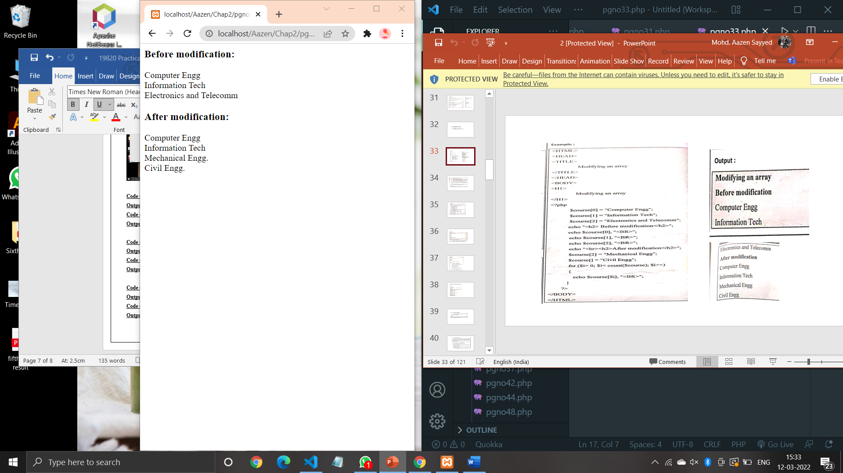

**Code (Pg no. 35):**

<?php

    $course = array("CO", "IF", "EJ", "ME", "CE");

    echo "<h3>Before Deletion: </h3><br>";

    echo "$course[0]<br>";

    echo "$course[1]<br>";

    echo "$course[2]<br>";

    echo "$course[3]<br>";

    echo "$course[4]<br>";

    unset($course[3]);

    echo "<h3>After Deletion: </h3><br>";

    print_r($course);

    echo "<h3>Delete entire array elements: </h3><br>";

    unset($course);

    ?>

**Output:**

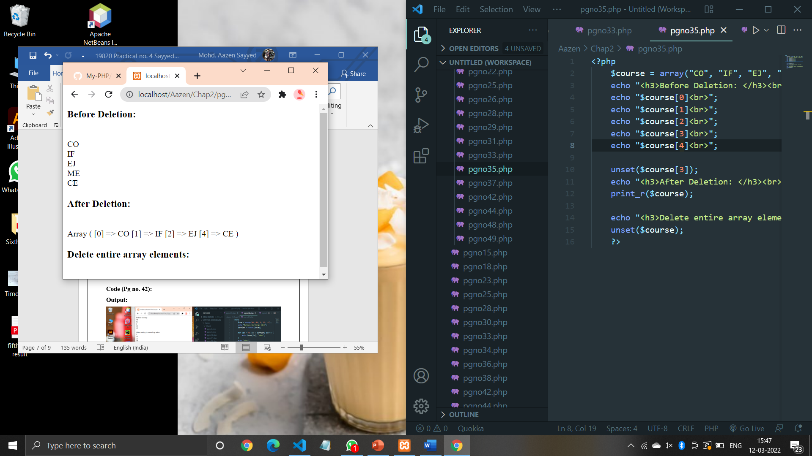

**Code (Pg no. 37):**

<?php

    $course[0] = "Computer Engg.";

    $course[1] = "Information Tech.";

    $course[2] = "Electronics and Telecomm.";

    echo "<h3>Before Deletion: </h3><br>";

    echo "$course[0]<br>";

    echo "$course[1]<br>";

    echo "$course[2]<br>";

    echo "<h3>After Deletion: </h3><br>";

    $course[2]="";

*for*($i=0;$i<count($course);$i++)

    {

        echo $course[$i],"<br>";

    }

    ?>

**Output:**

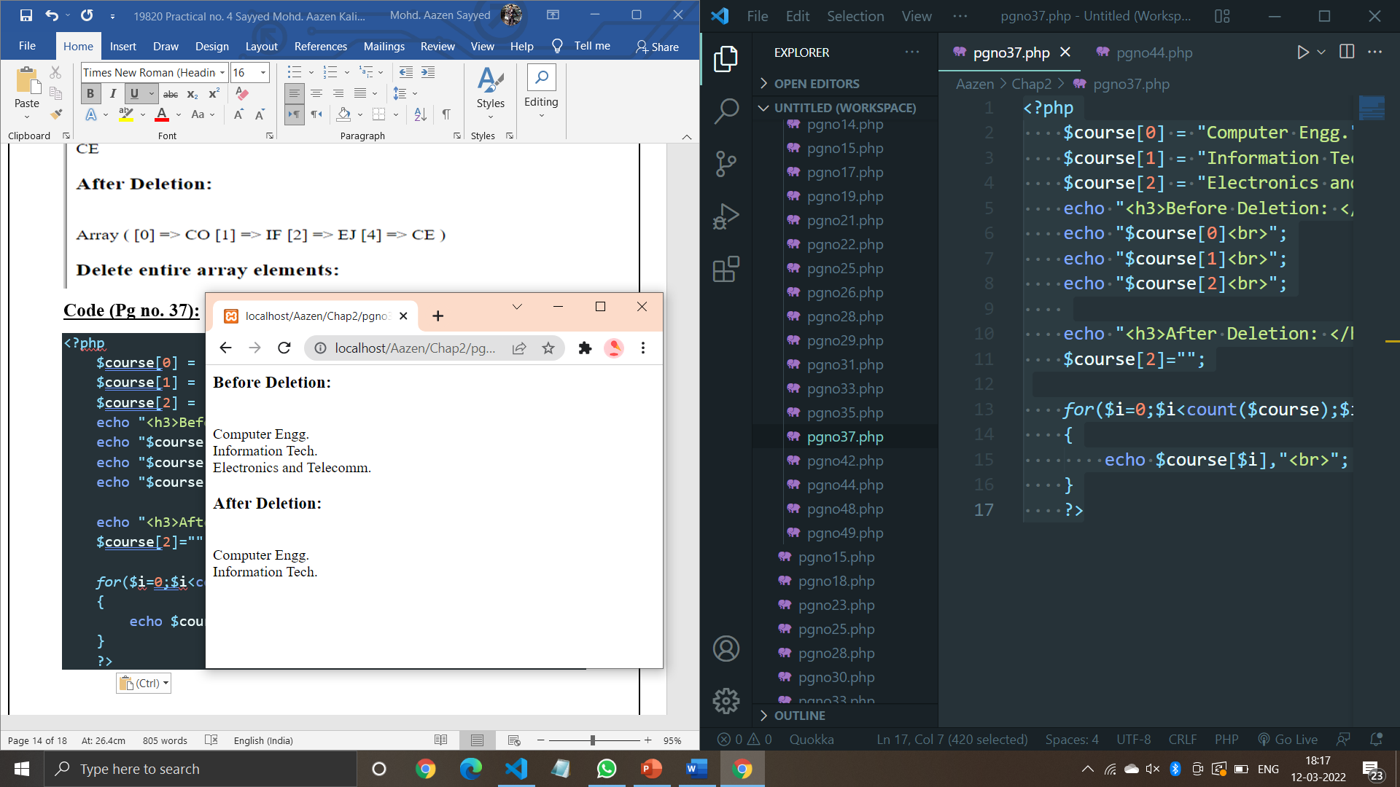

**Code (Pg no. 42):**

<?php

    $num = array(40, 61, 2, 22, 13);

    echo "Before Sorting: <br>";

    $arrlen = count($num);

*for* ($x = 0; $x < $arrlen; $x++) {

        echo $num[$x], "<br>";

    }

    echo "<br>";

    sort($num);

    echo "After sorting in ascending order: <br>";

    $arrlen = count($num);

*for* ($x = 0; $x < $arrlen; $x++) {

        echo $num[$x], "<br>";

    }

    echo "<br>";

    echo "After sorting in descending order: <br>";

    rsort($num);

    $arrlen = count($num);

*for* ($x = 0; $x < $arrlen; $x++) {

        echo $num[$x], "<br>";

    }

    ?>

**Output:**

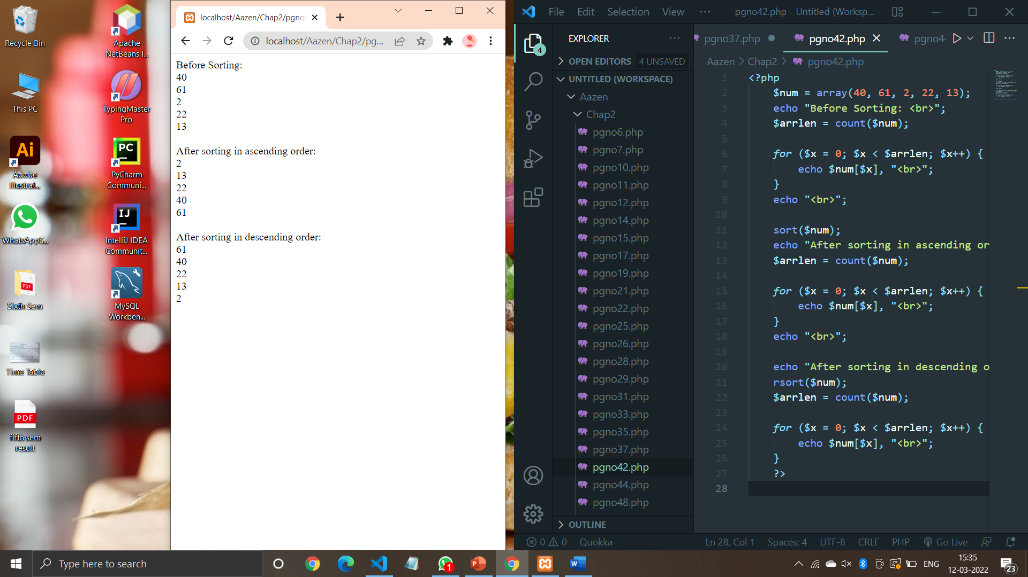

**Code (Pg no. 44):**

<?php

$percent = array("Aazen"=>"80","Yogita"=>"78","Siddhesh"=>"68");

echo "<b>Sorting according to Value:</b><br>";

asort($percent);

*foreach*($percent as $x=>$x_value)

{

    echo "Key=".$x."Value=".$x_value;

    echo "<br>";

}

echo "<br><br><b>Sorting according to Key:</b><br>";

ksort($percent);

*foreach*($percent as $x=>$x_value)

{

    echo "Key=".$x.",Value=".$x_value;

    echo "<br>";

}

?>

**Output:**

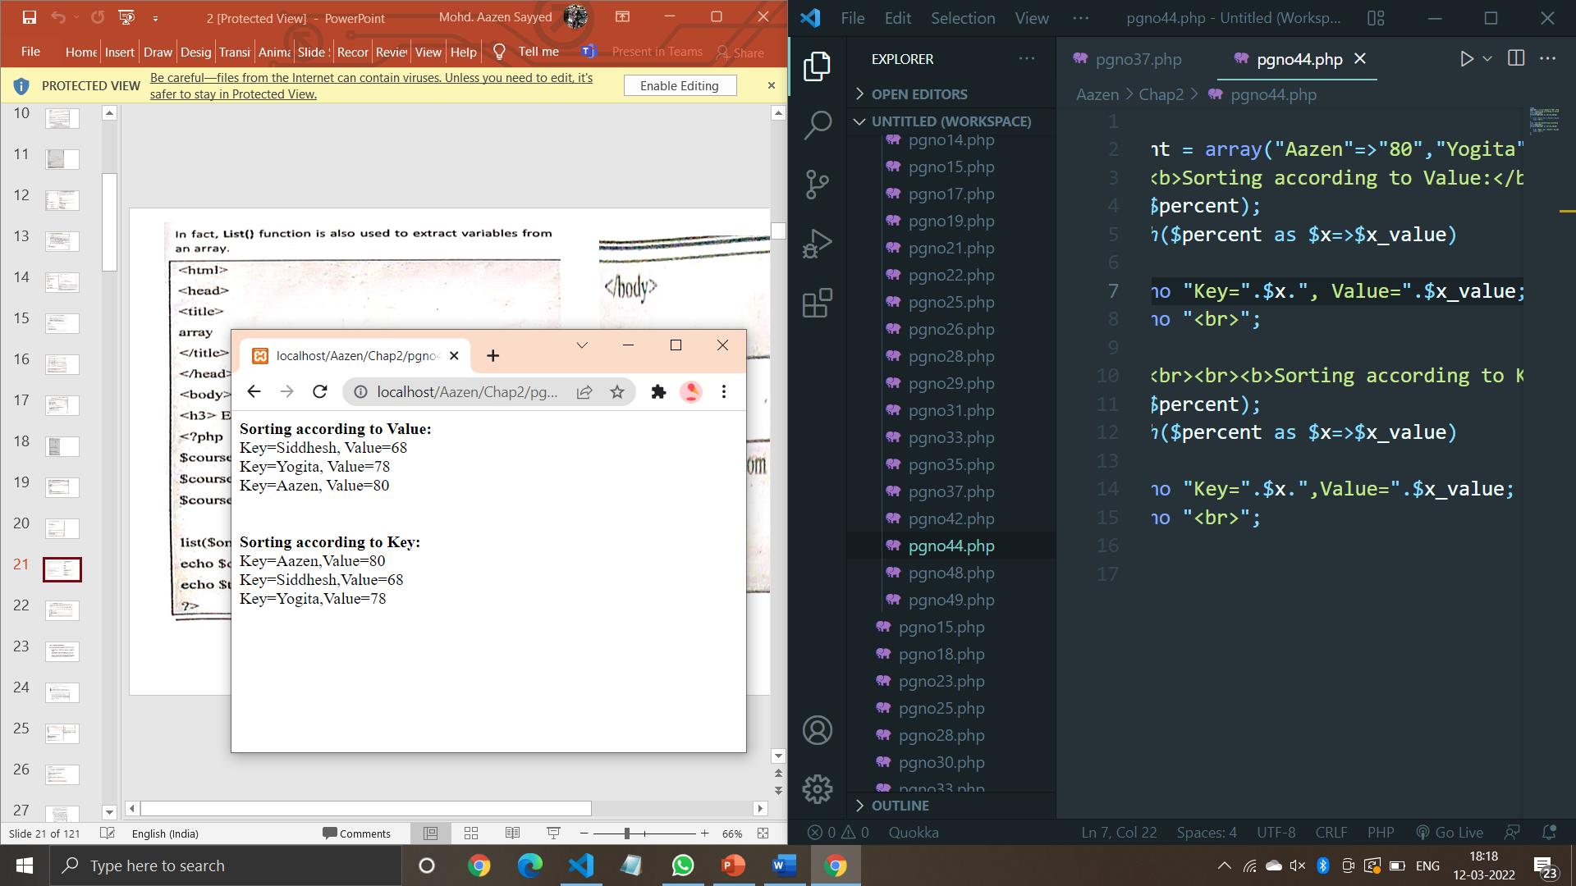

**Code (Pg no. 48):**

<?php

    $course[0]="Computer Engineering";

    $course[1]="Information Technology";

    $course[2]="Electronics and Telecommunication";

    echo "<h3>Before splitting array: </h3>";

    echo $course[0], "<br>";

    echo $course[1], "<br>";

    echo $course[2], "<br>";

    echo "<h3>After splitting array: </h3>";

    $subarray = array_slice($course, 0,3);

*foreach* ($subarray as $value) {

        echo "Course: $value<br>";

    }

    ?>

**Output:**

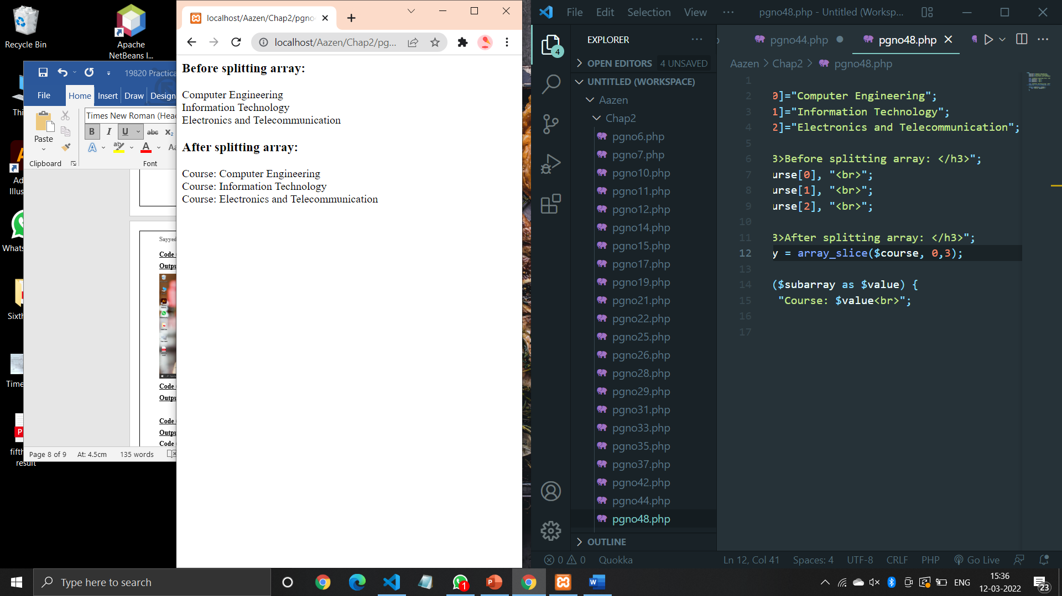

**Code (Pg no. 49):**

<?php

    $sem3 = array("Object Oriented Programming", "Principle of Database", "Data Structure");

    $sem4 = array("Database Management", "Java Programming", "Software Engg.", "Computer Network");

    $subject = array_merge($sem3,$sem4);

*foreach* ($subject as $value) {

        echo "Subject: $value<br>";

    }

    ?>

**Output:**

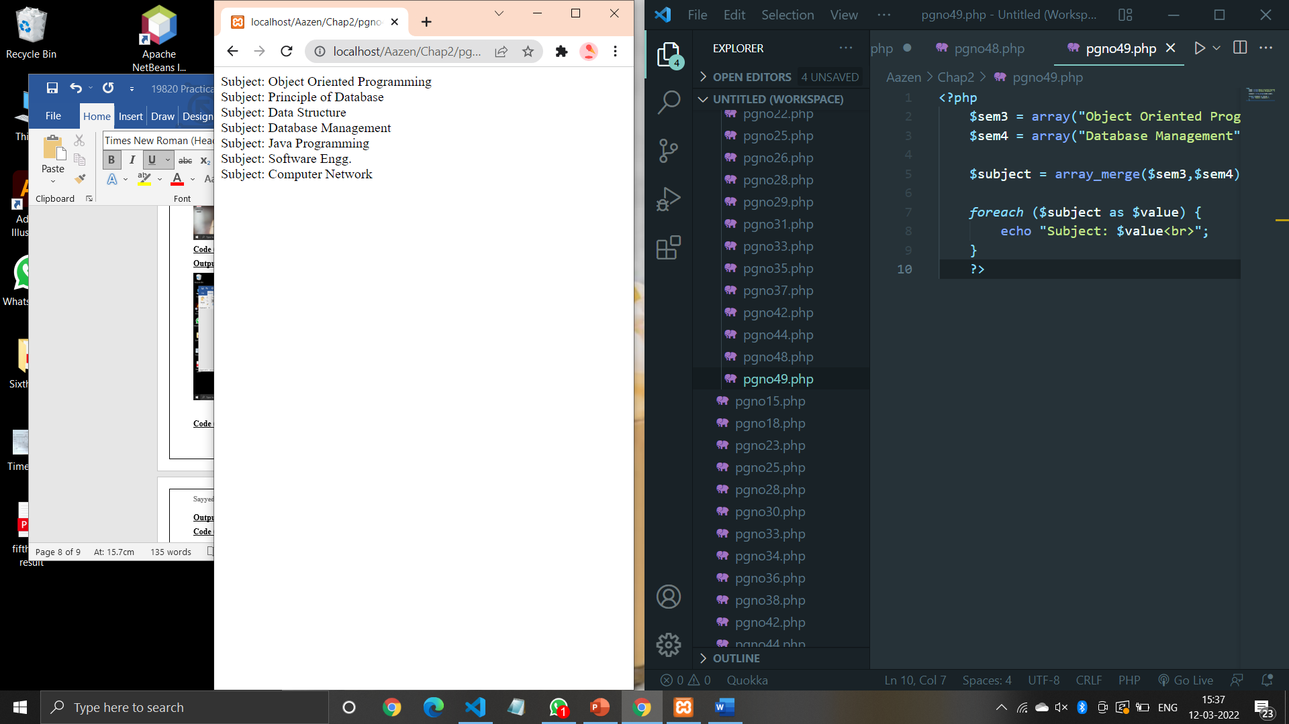

**Code (Pg no. 50):**

<?php

$a1=array('PHP','C','Java','Perl');

$a2=array('PHP','ASP','Java','Python');

$a=array_diff($a1,$a2);

print_r($a);

?>

**Output:**

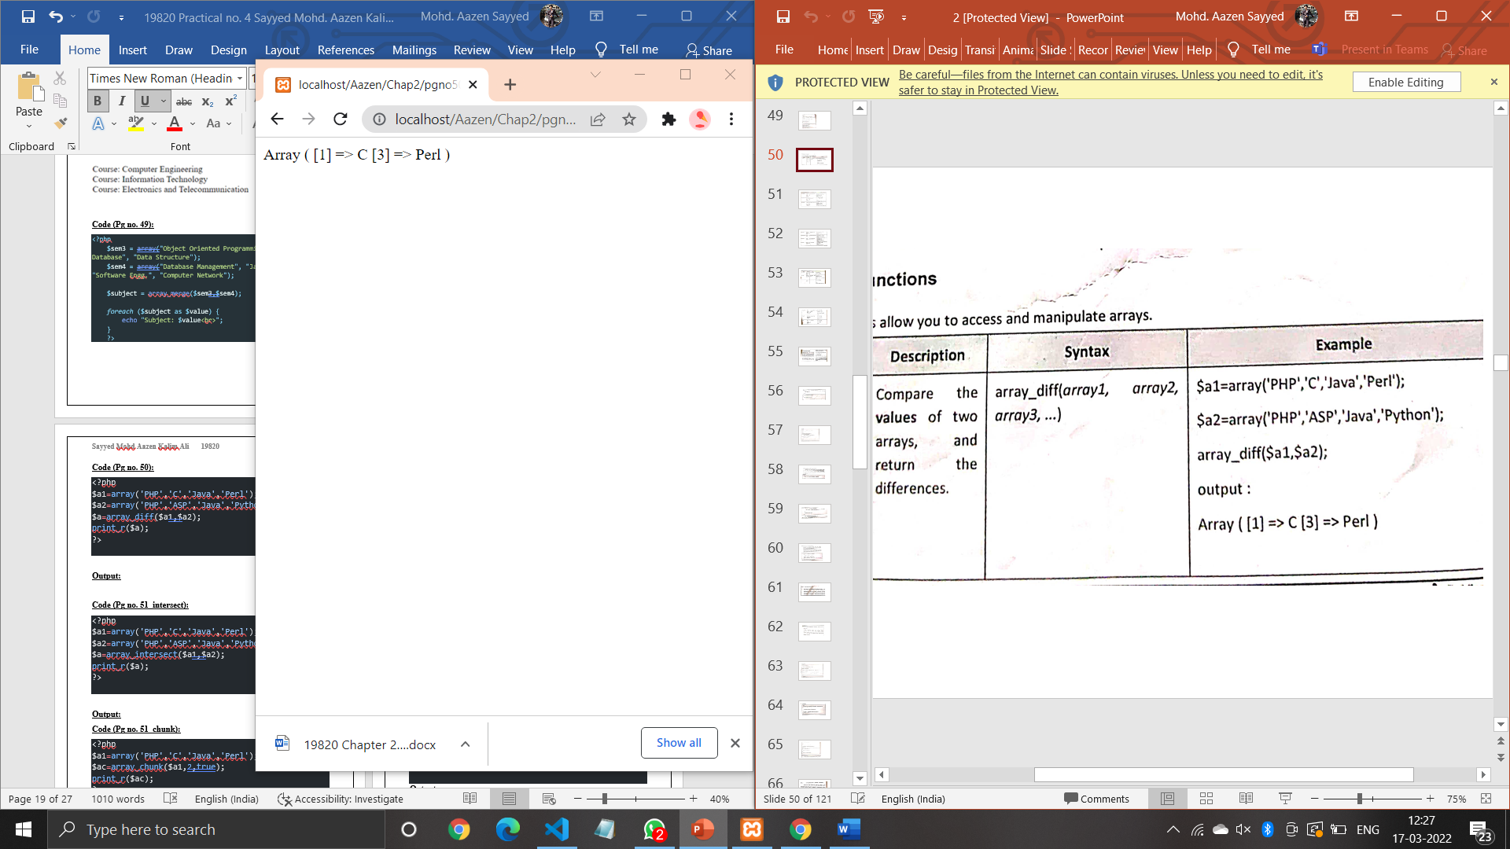

**Code (Pg no. 51_intersect):**

<?php

$a1=array('PHP','C','Java','Perl');

$a2=array('PHP','ASP','Java','Python');

$a=array_intersect($a1,$a2);

print_r($a);

?>

**Output:**

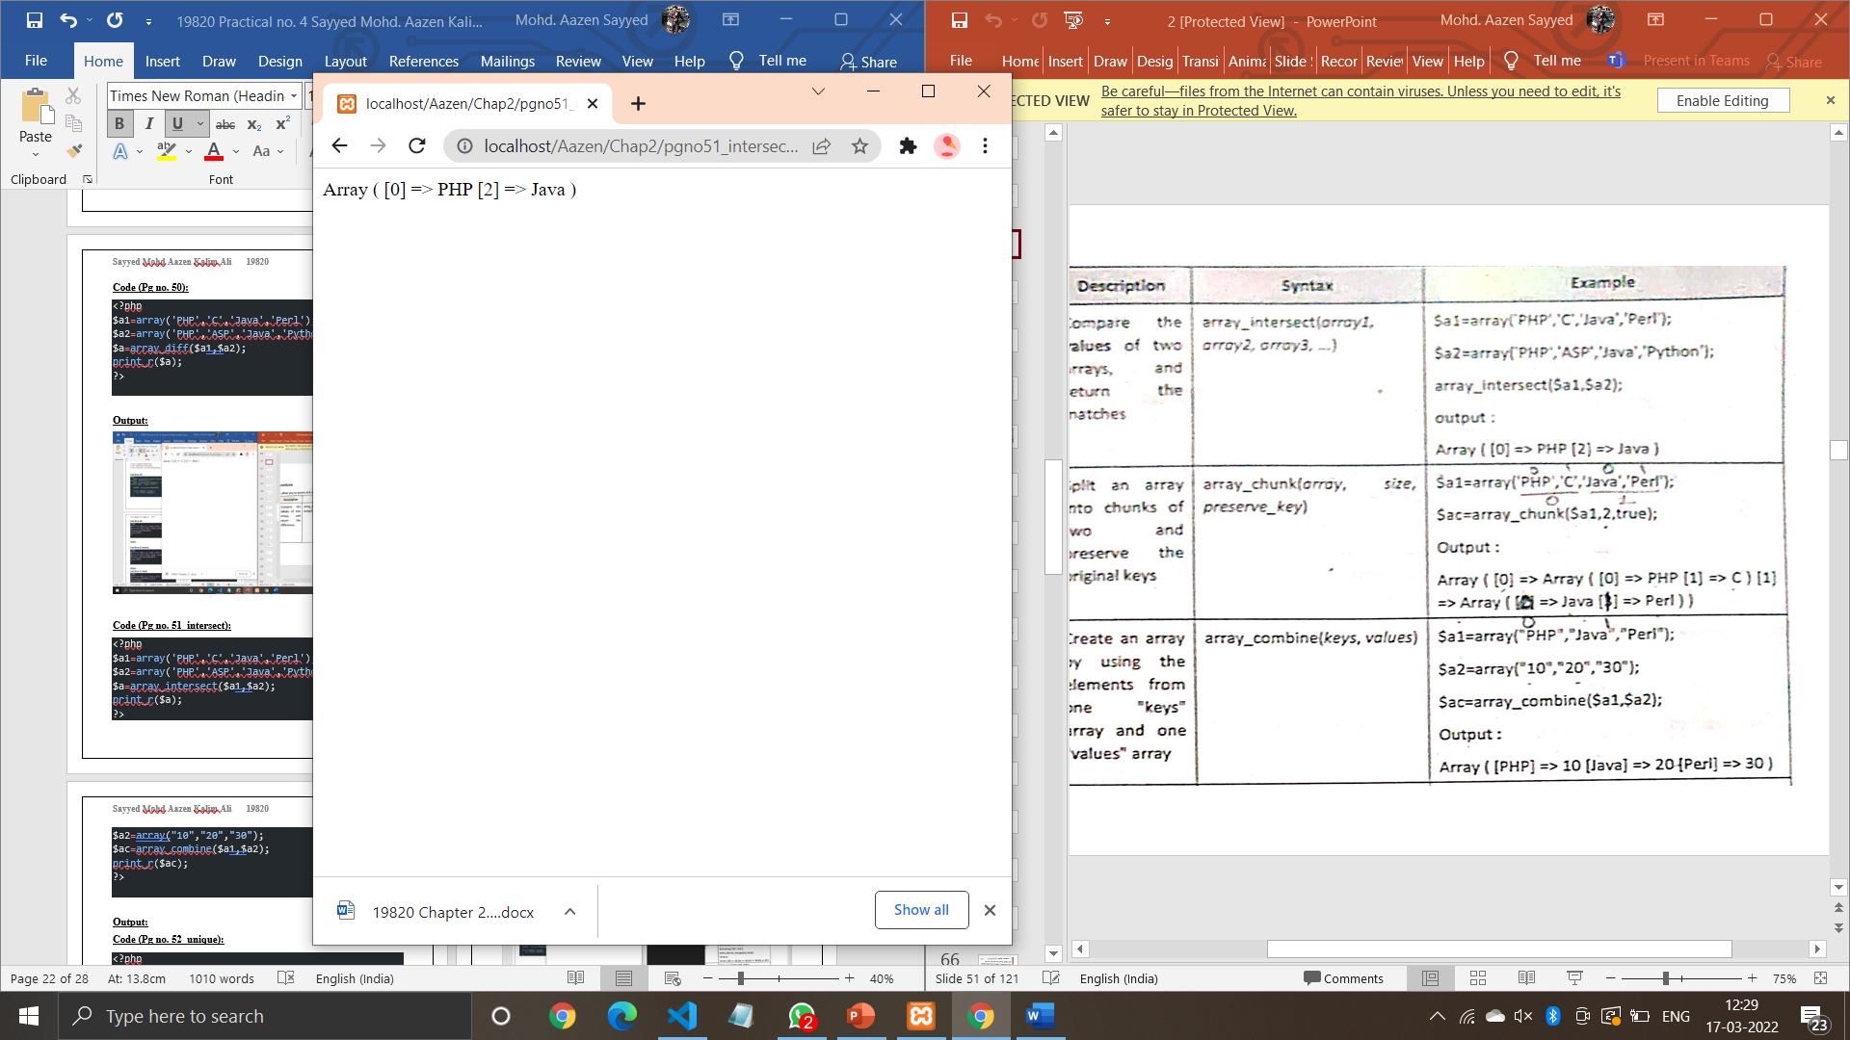

**Code (Pg no. 51_chunk):**

<?php

$a1=array('PHP','C','Java','Perl');

$ac=array_chunk($a1,2,true);

print_r($ac);

?>

**Output:**

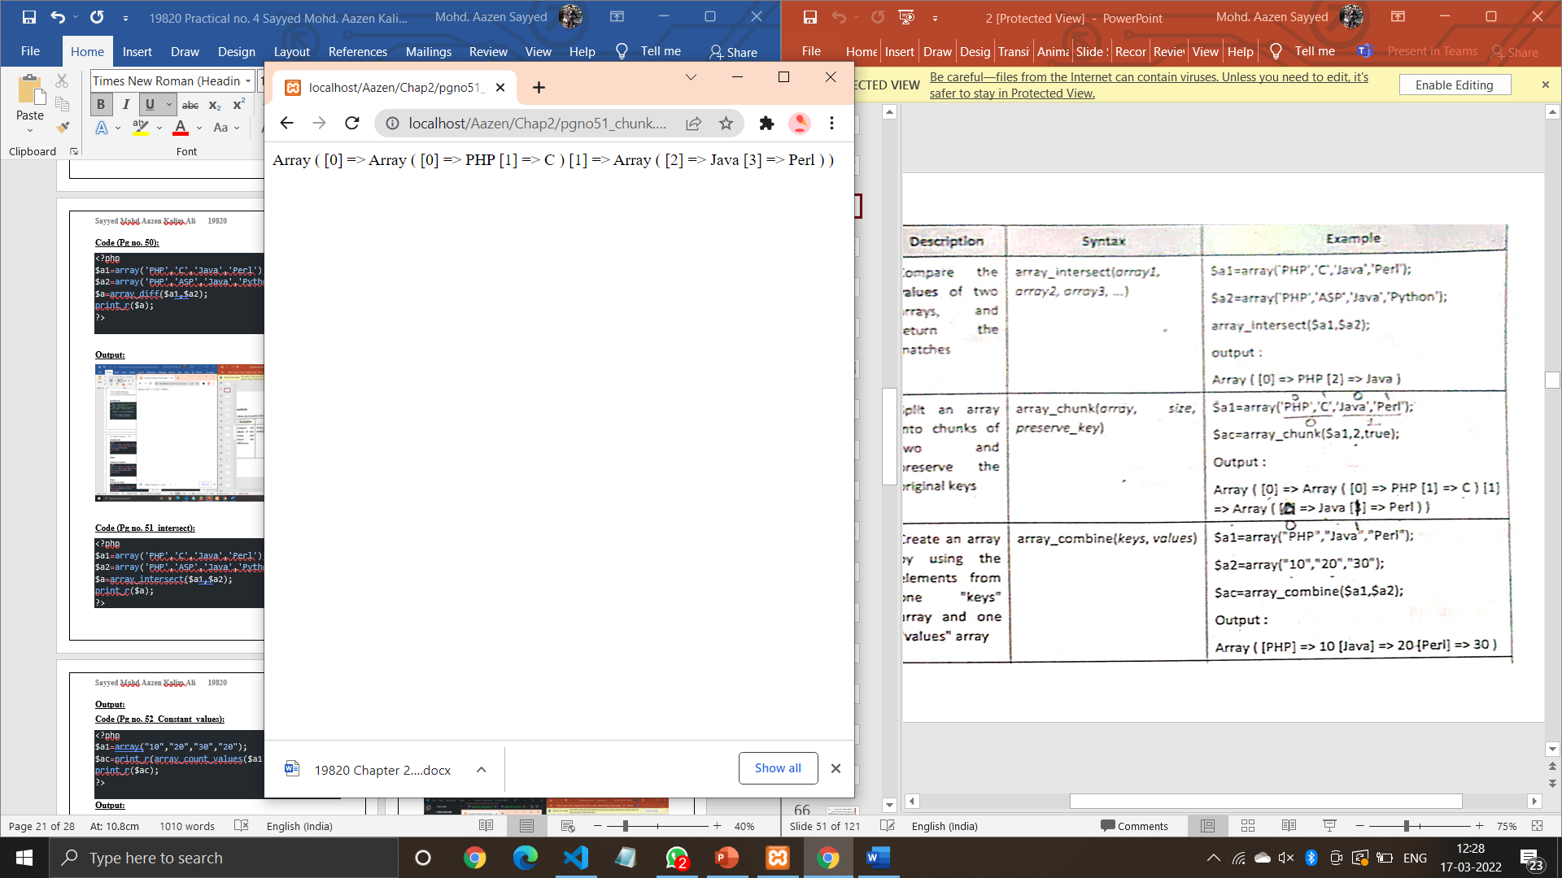

**Code (Pg no. 51_combine):**

<?php

$a1=array("PHP","Java","Perl");

$a2=array("10","20","30");

$ac=array_combine($a1,$a2);

print_r($ac);

?>

**Output:**

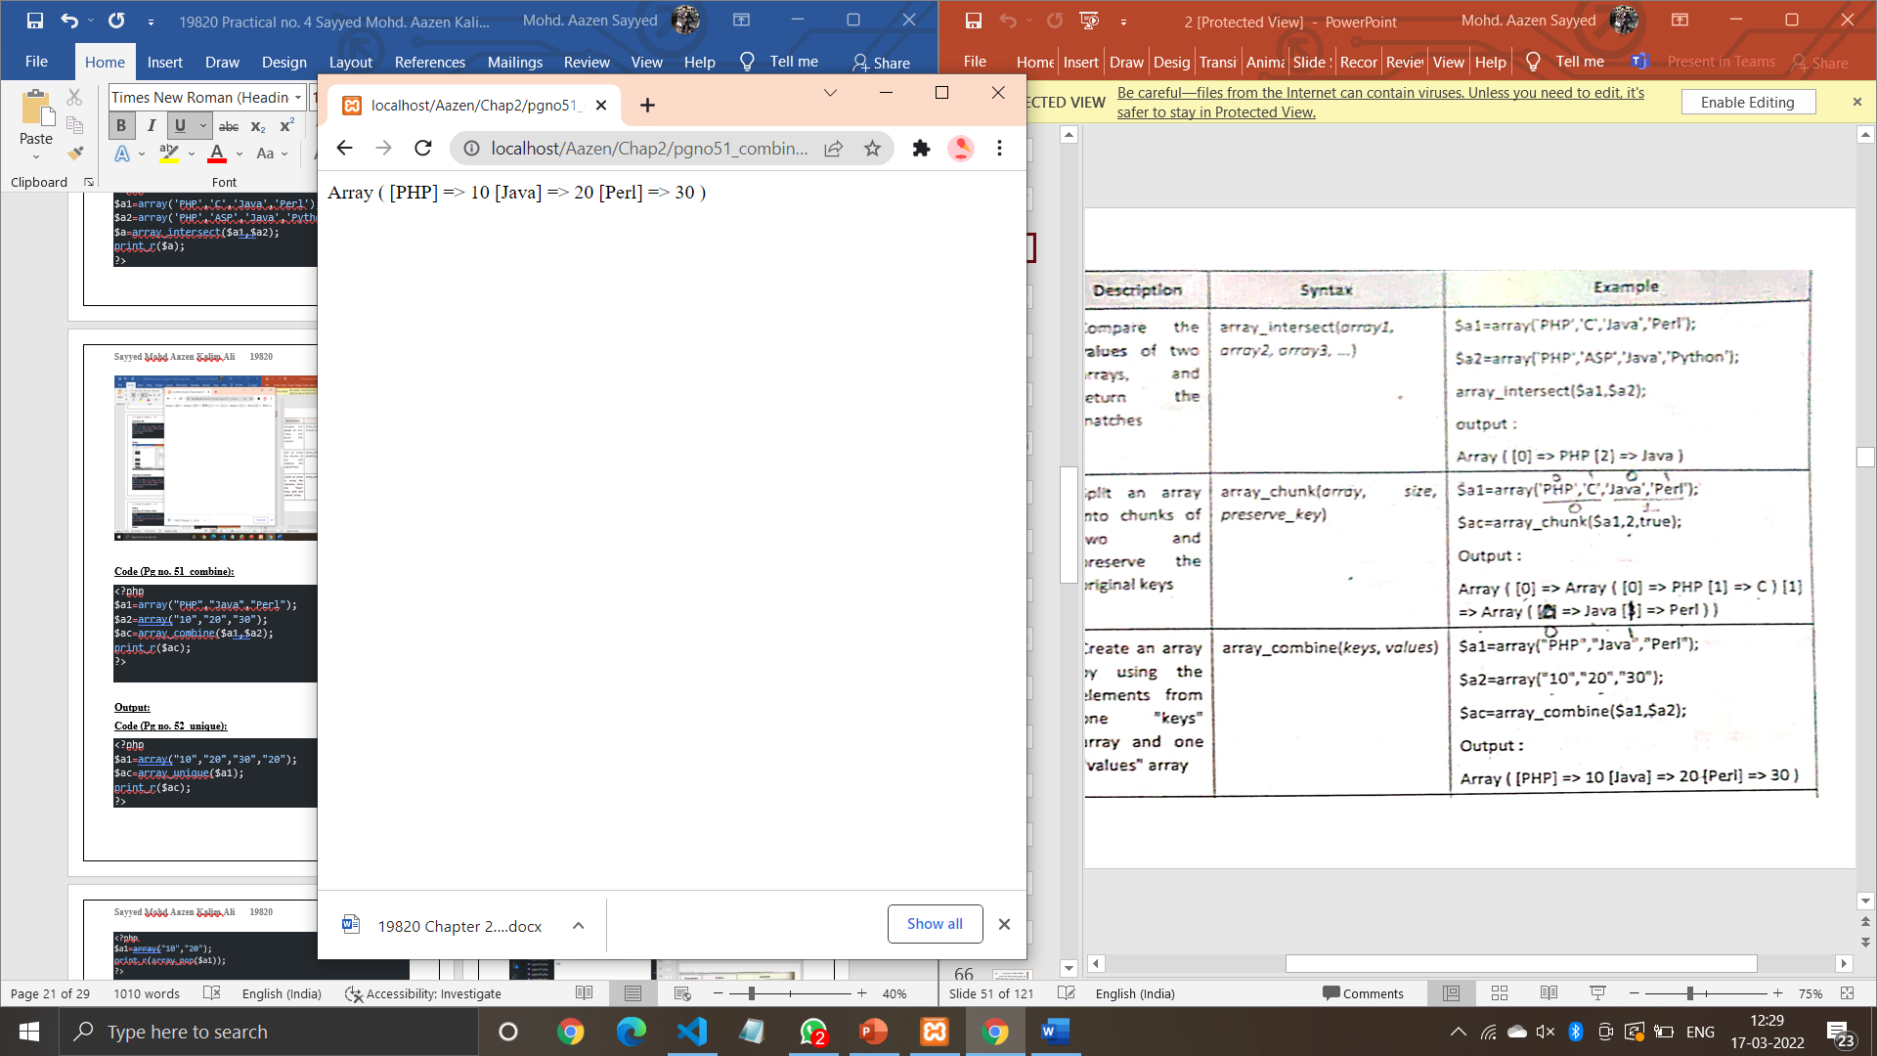

**Code (Pg no. 52_unique):**

<?php

$a1=array("10","20","30","20");

$ac=array_unique($a1);

print_r($ac);

?>

**Output:**

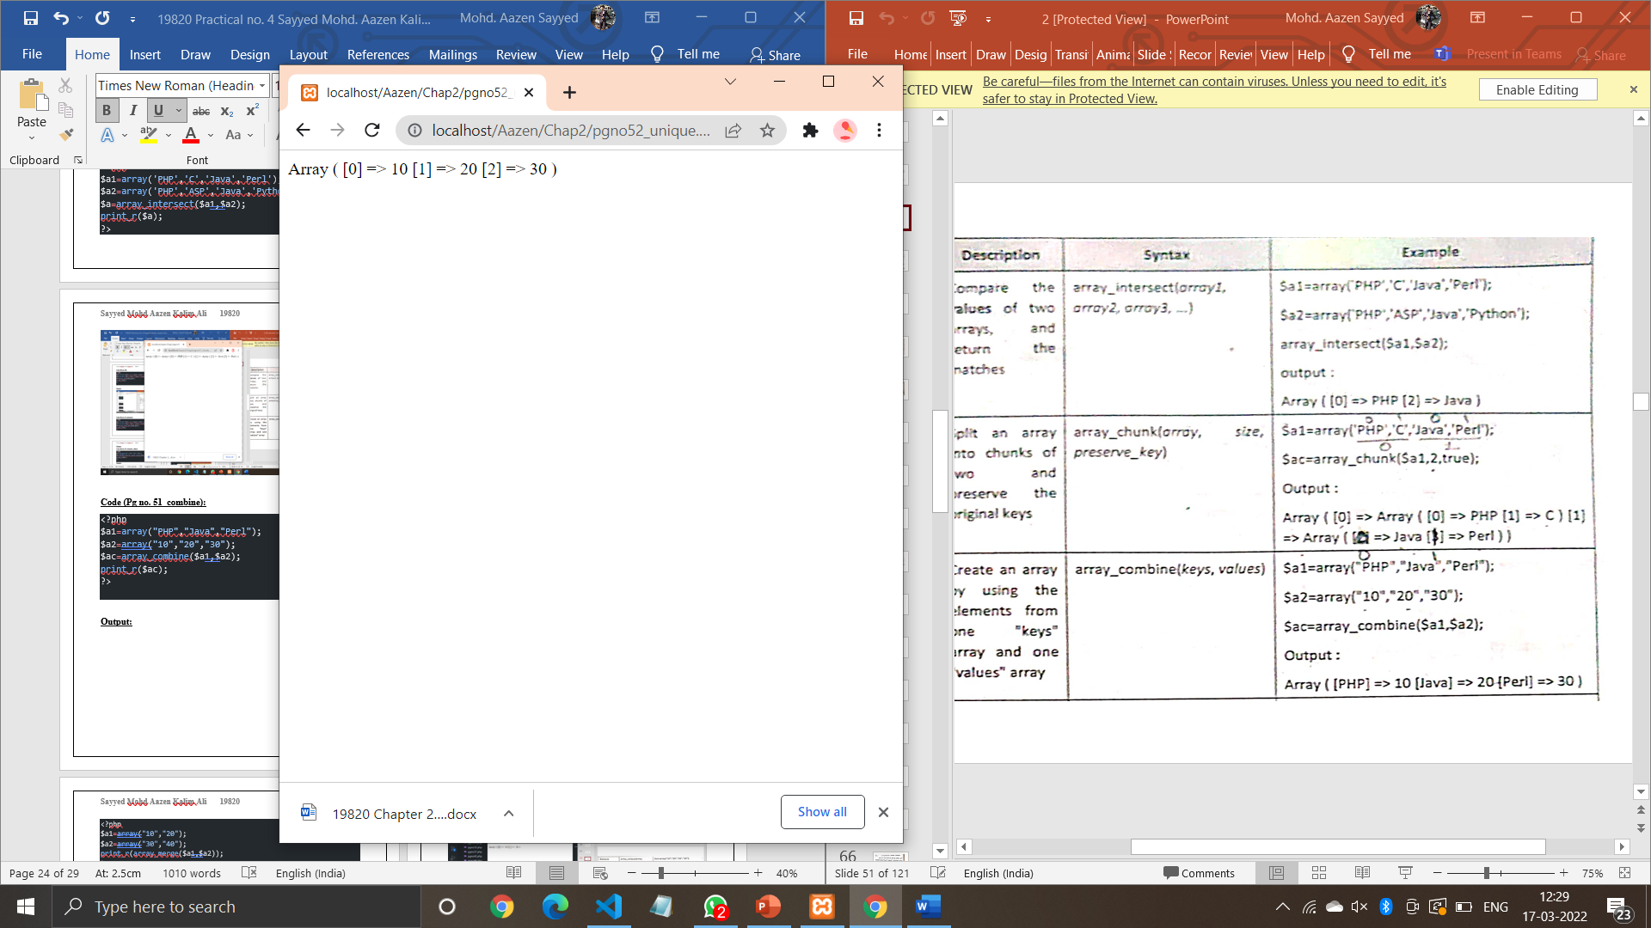

**Code (Pg no. 52_Count_values):**

<?php

$a1=array("10","20","30","20");

print_r(array_count_values($a1));

?>

**Output:**

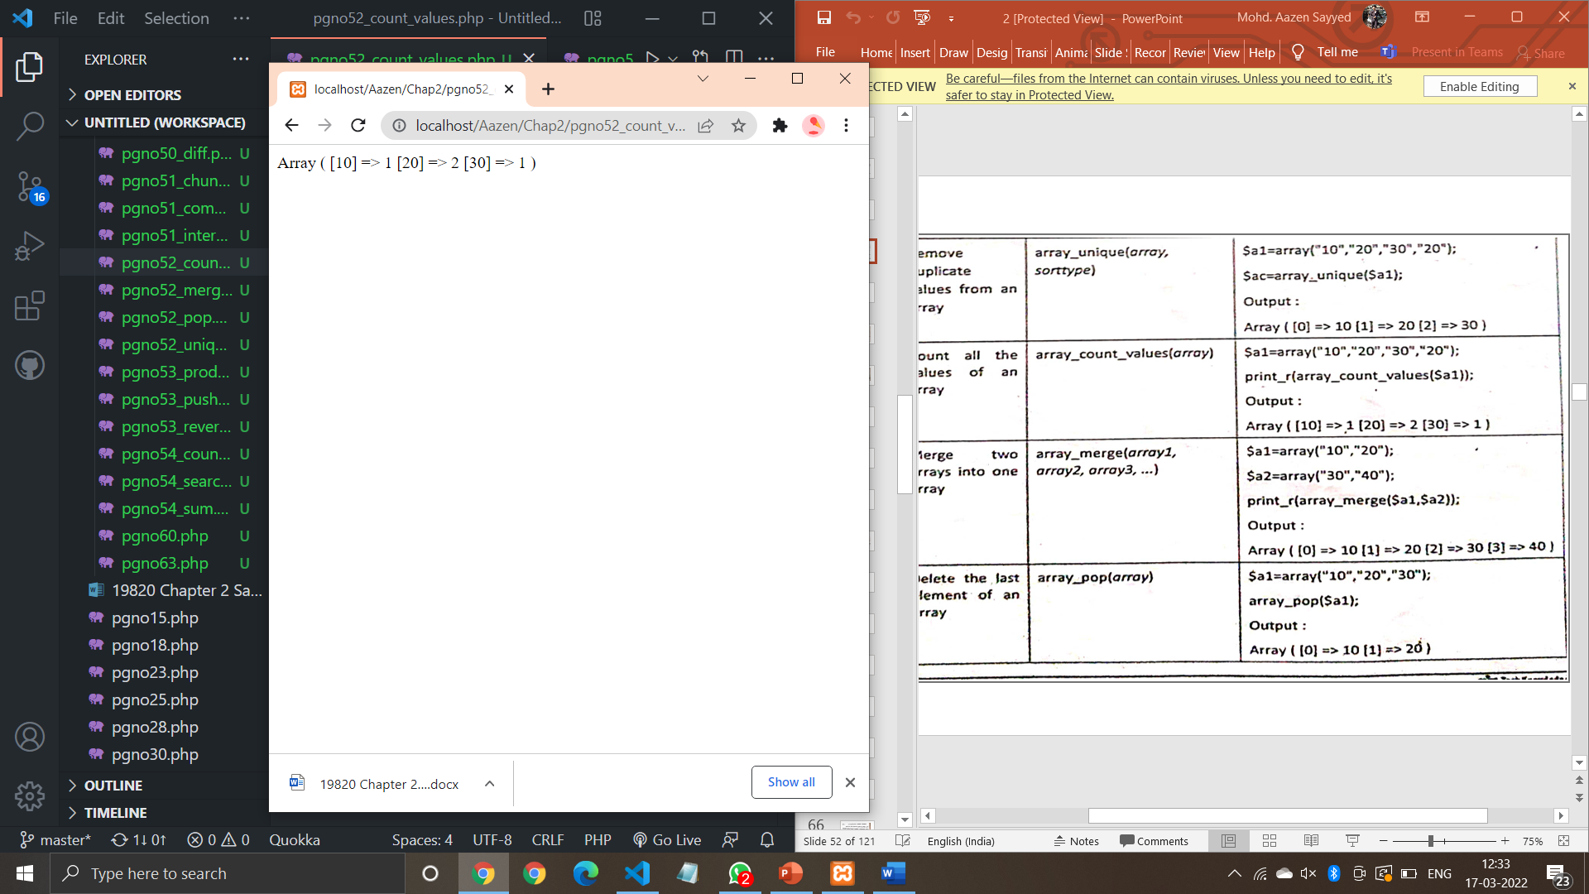

**Code (Pg no. 52_merge):**

<?php

$a1=array("10","20");

$a2=array("30","40");

print_r(array_merge($a1,$a2));

?>

**Output:**

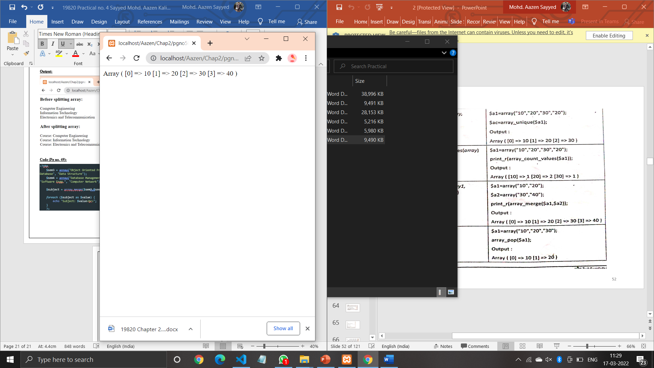

**Code (Pg no. 52_pop):**

<?php

$a1=array("10","20");

print_r(array_pop($a1));

?>

**Output:**

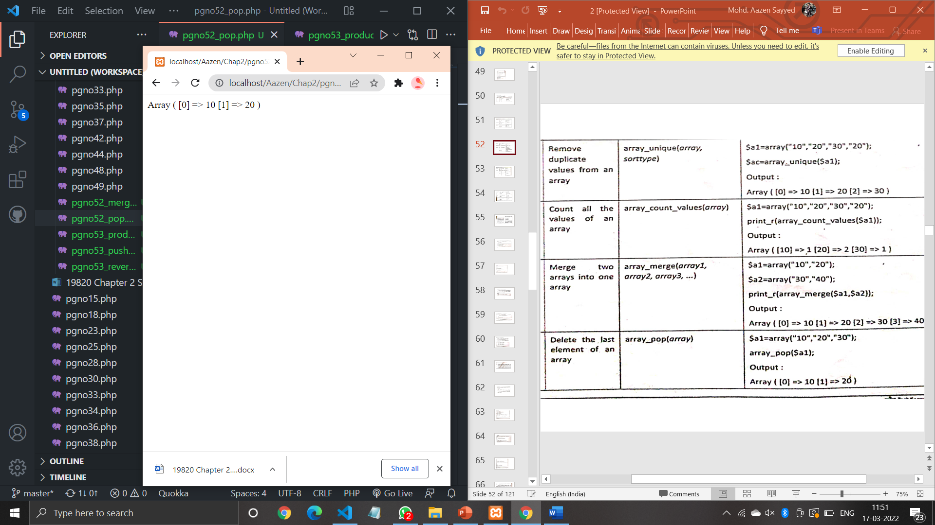

**Code (Pg no. 53_product):**

<?php

$a1=array("10","20");

echo(array_product($a1));

?>

**Output:**

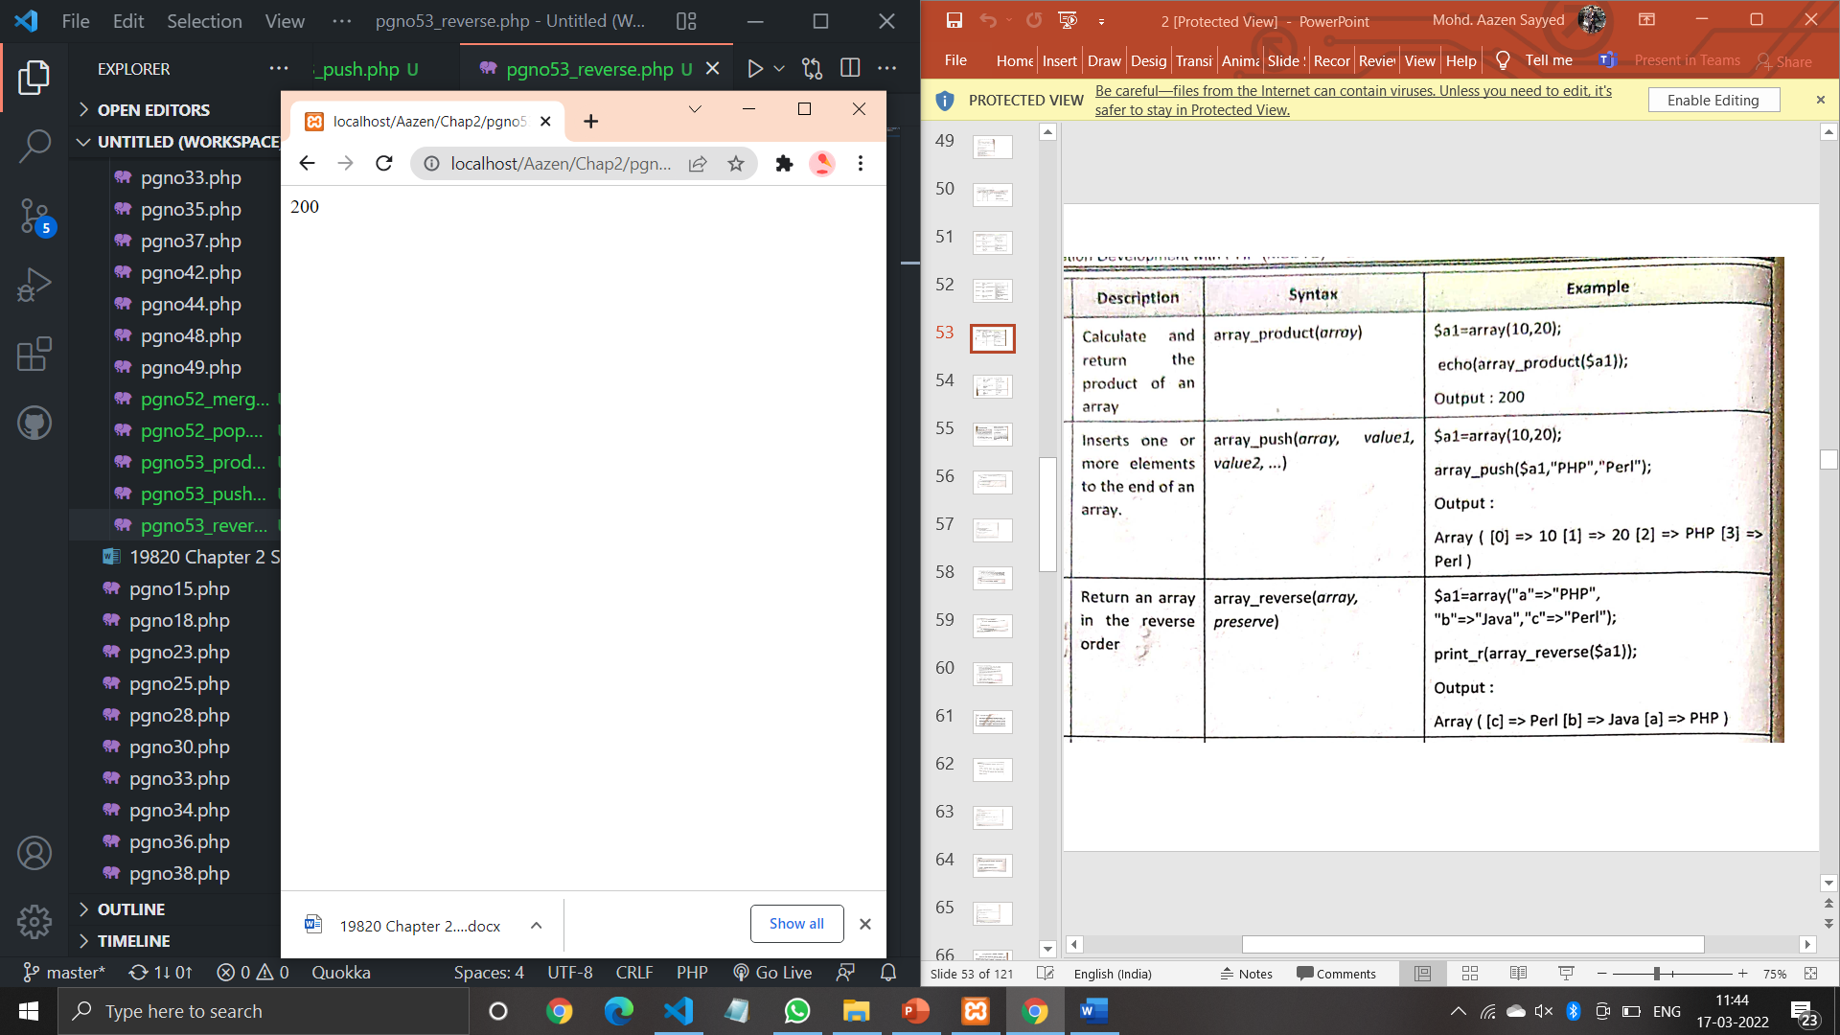

**Code (Pg no. 53_push):**

<?php

$a1=array(10,20);

(array_push($a1,"PHP","Perl"));

print_r($a1);

?>

**Output:**

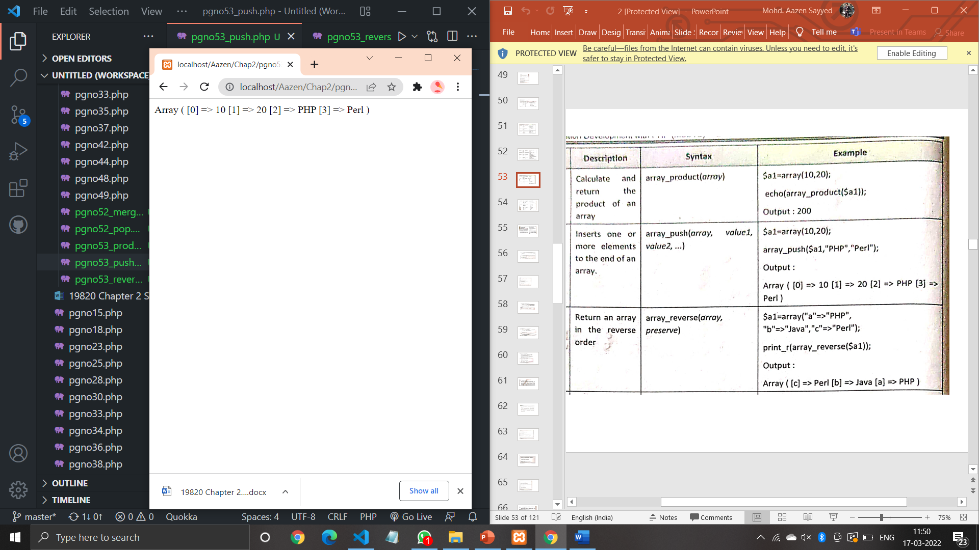

**Code (Pg no. 53_reverse):**

<?php

$a1=array("a"=>"PHP","b"=>"Java","c"=>"Perl");

print_r(array_reverse($a1));

?>

**Output:**

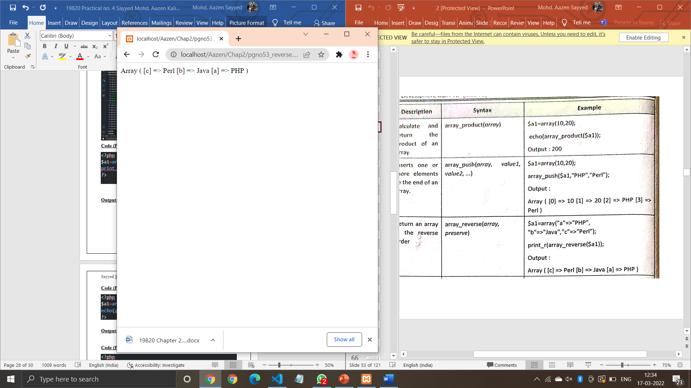

**Code (Pg no. 54_search):**

<?php

$a1=array("a"=>"PHP","b"=>"Java","c"=>"Perl");

echo(array_search("Java",$a1))

?>

**Output:**

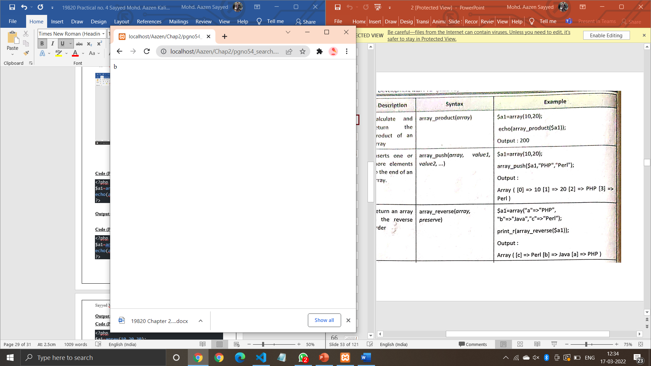

**Code (Pg no. 54_sum):**

<?php

$a1=array(10,20,30);

echo(array_sum($a1))

?>

**Output:**

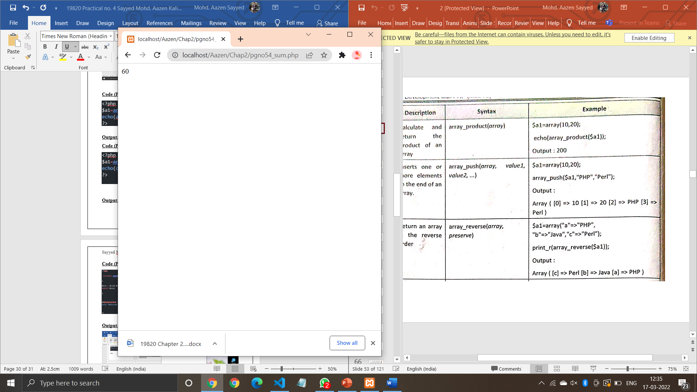

**Code (Pg no. 54_count):**

<?php

$a1=array(10,20,30);

echo(count($a1))

?>

**Output:**

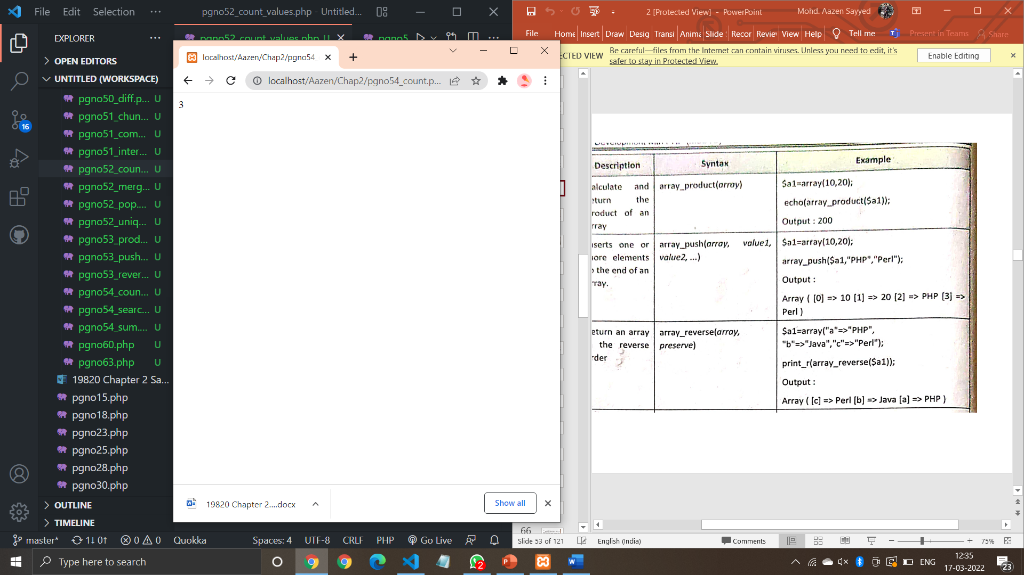

**Code (Pg no. 57):**

<?php

function writeMessage(){

    echo "This is an Example of Functions without parameters";

}

writeMessage();

?>

**Output:**

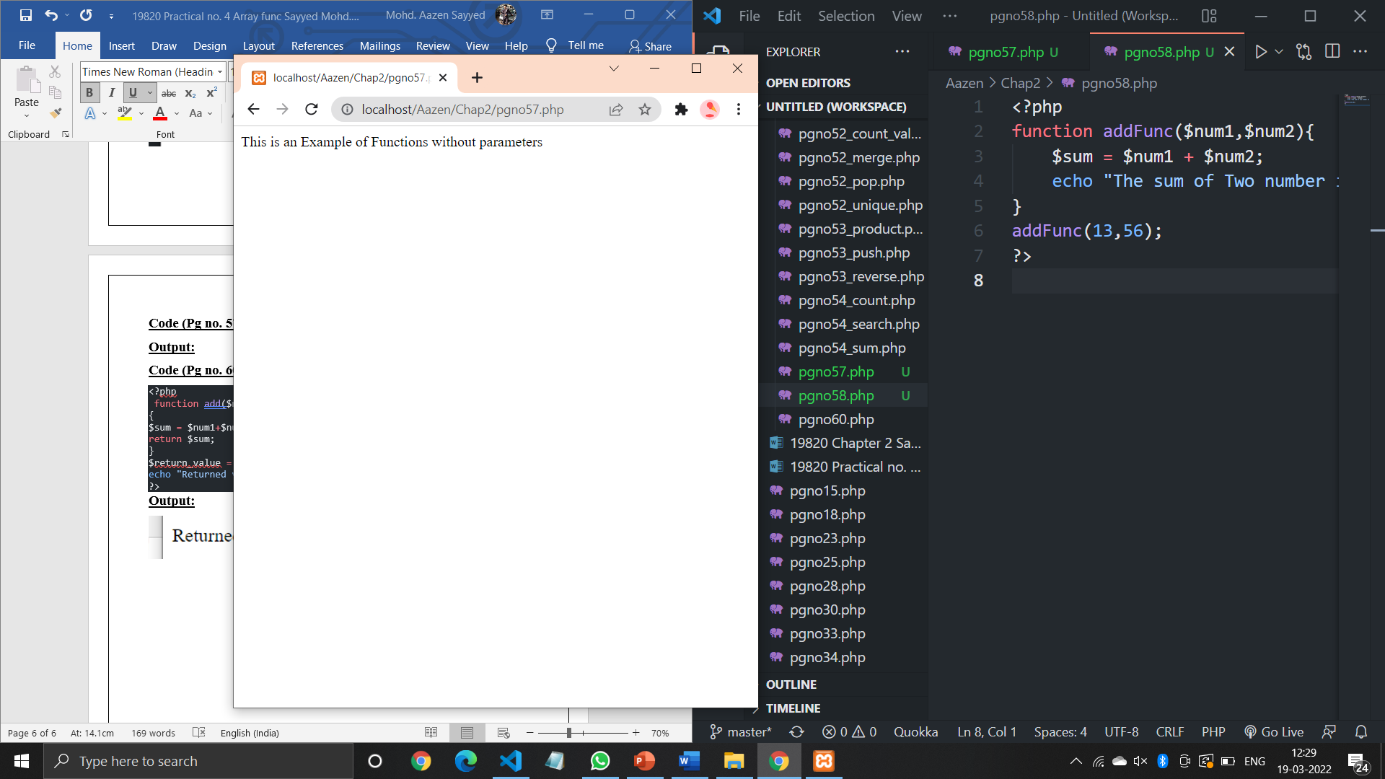

**Code (Pg no. 58):**

<?php

function addFunc($num1,$num2){

    $sum = $num1 + $num2;

    echo "The sum of Two number is : $sum";

}

addFunc(17,96);

?>

**Output:**

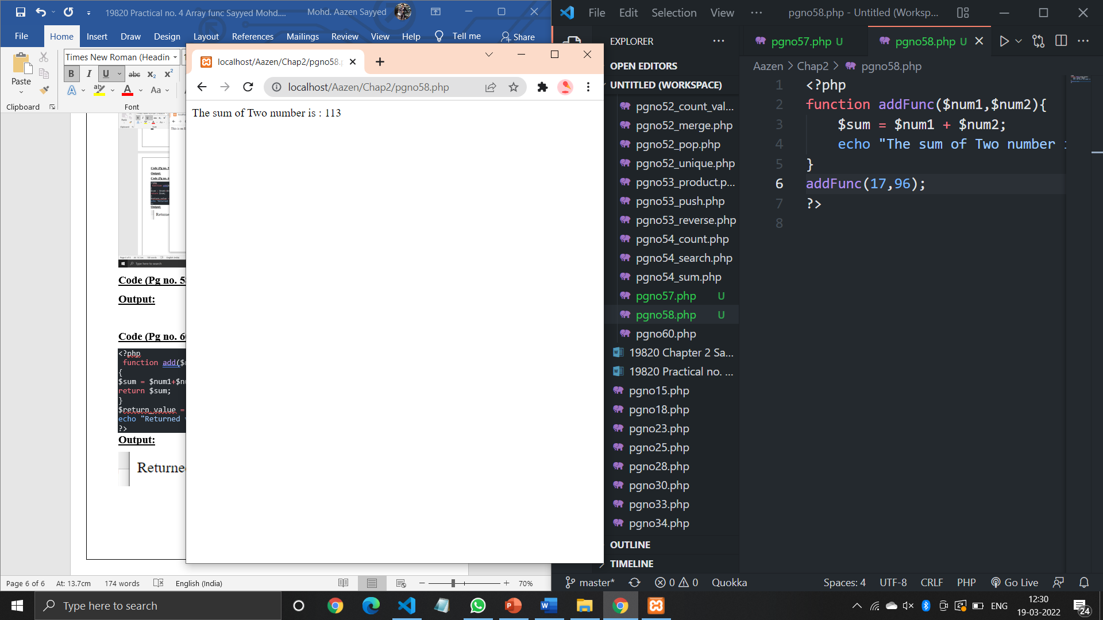

**Code (Pg no. 60):**

<?php

 function add($num1, $num2)

{

$sum = $num1+$num2;

return $sum;

}

$return_value = add(50, 20);

echo "Returned value from the function: $return_value";

?>

**Output:**

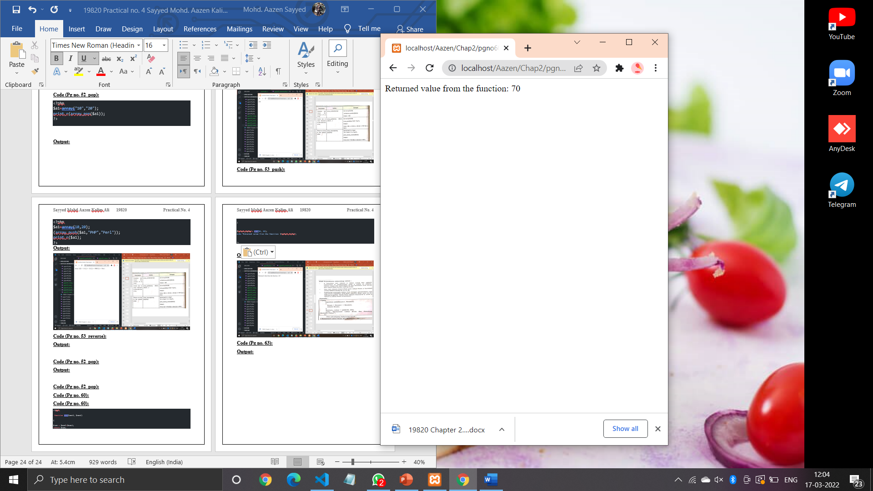

**Code (Pg no. 63):**

<?php

    function simple(){

        echo "In simple()<br />\n";

    }

    function data($arg = " ")

    {

        echo "In data(); argument was '$arg'.<br>\n";

    }

    $func = 'simple';

    $func();

    $func = 'data';

    $func('test');

    ?>

**Output:**

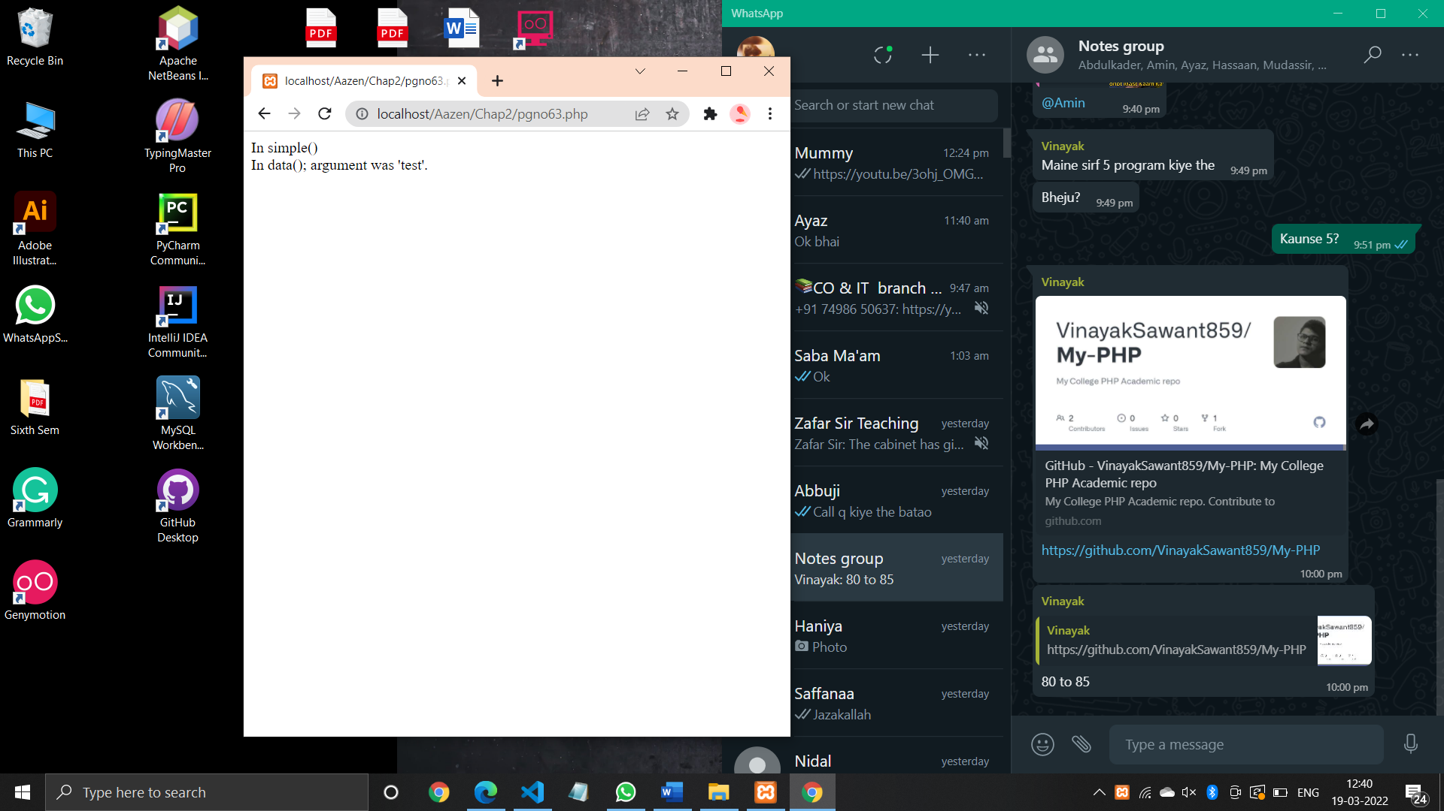

**Code (Pg no. 64):**

<?php

    $function = function(){

        echo 'Information Technology';

    };

    if(is_callable($function))

    {

      echo "It is Function";

    }

    else

    {

        echo "It is not Function";

    }

    $var = "IF";

    echo "<br>";

    if(is_callable($var))

    {

        echo "It is function";

    }

    else

    {

        echo "It is not function";

    }

    ?>

**Output:**

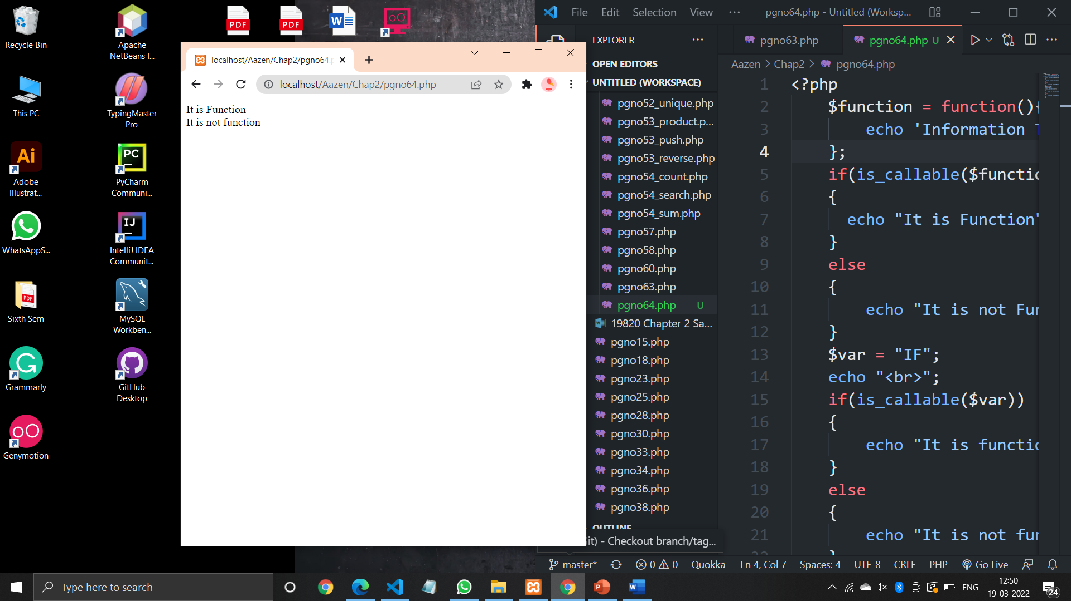

**Code (Pg no. 82_str_word_count):**

<?php

echo str_word_count("Welcome to PHP world!");

?>

**Output:**

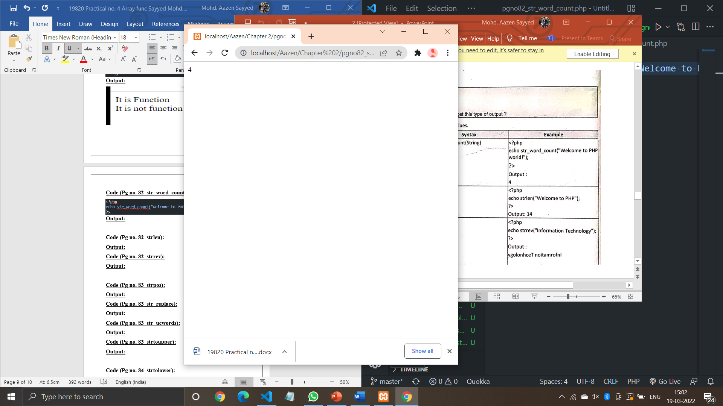

**Code (Pg no. 82_strlen):**

<?php

echo strlen("Welcome to PHP");

?>

**Output:**

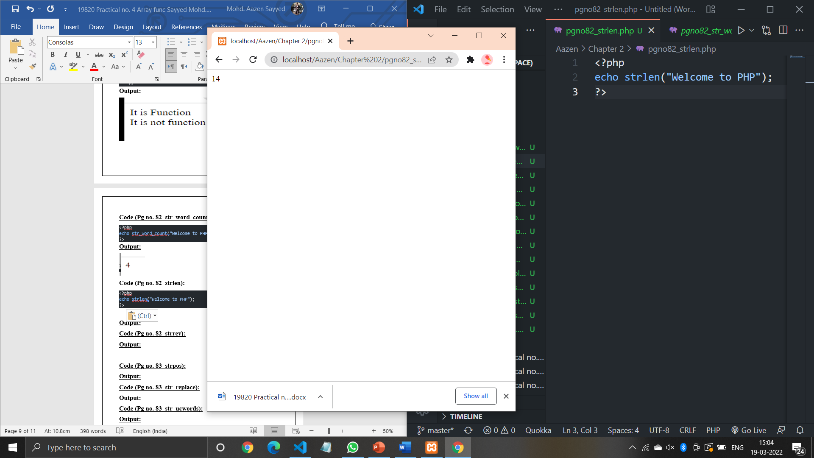

**Code (Pg no. 82_strrev):**

<?php

echo strrev("Sayyed Mohd Aazen Kalim Ali");

?>

**Output:**

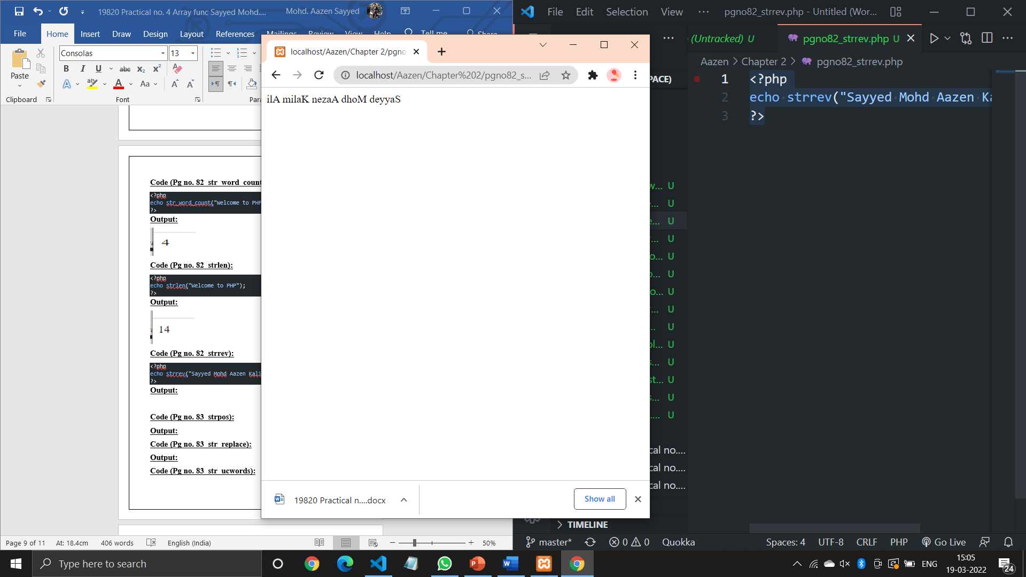

**Code (Pg no. 83_strpos):**

<?php

echo strpos("PHP contains for loop,for each and while loop","loop");

?>

**Output:**

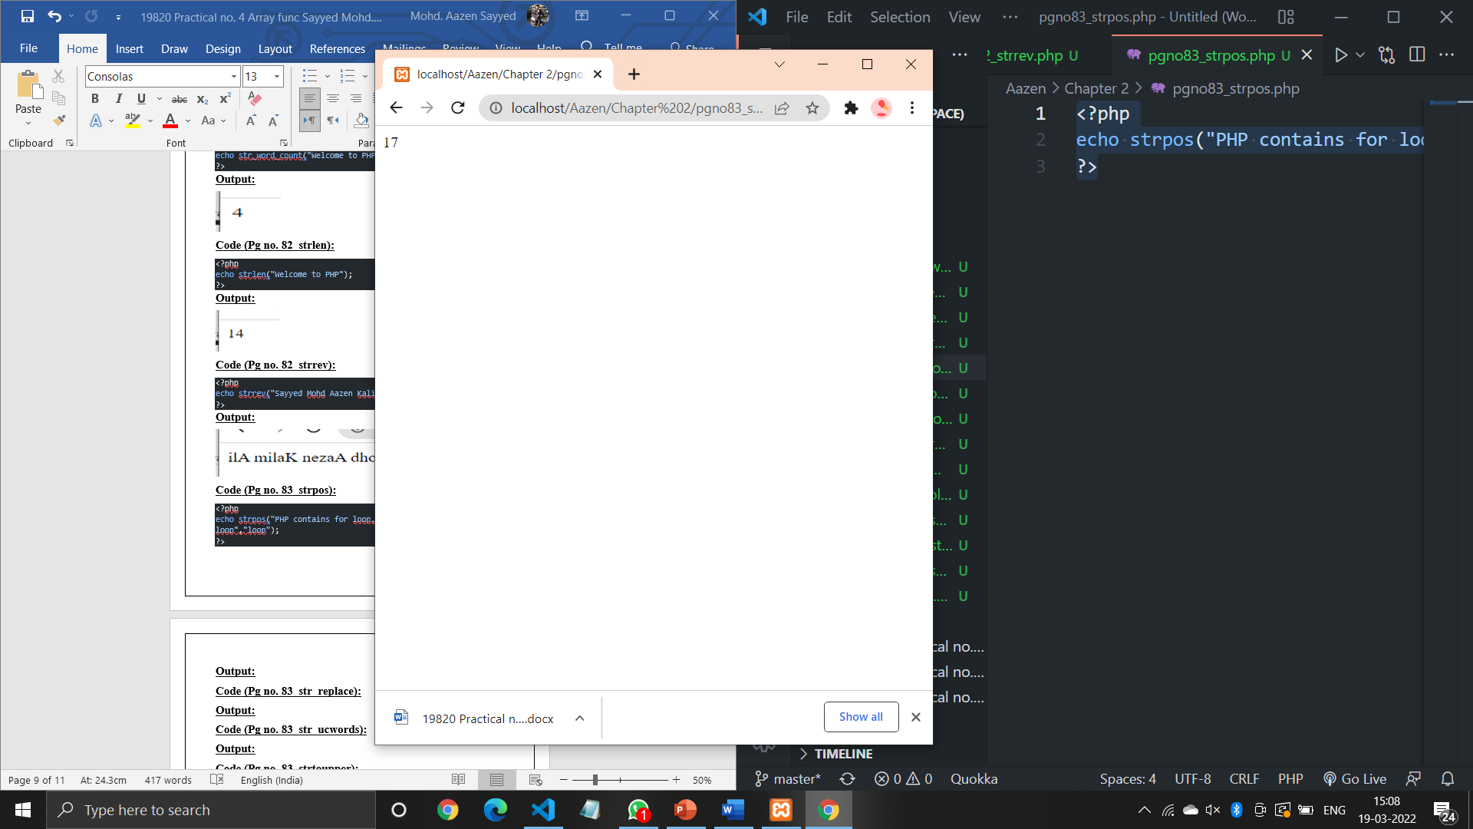

**Code (Pg no. 83_str_replace):**

<?php

echo str_replace("Clock","Click","Click and Clock");

?>

**Output:**

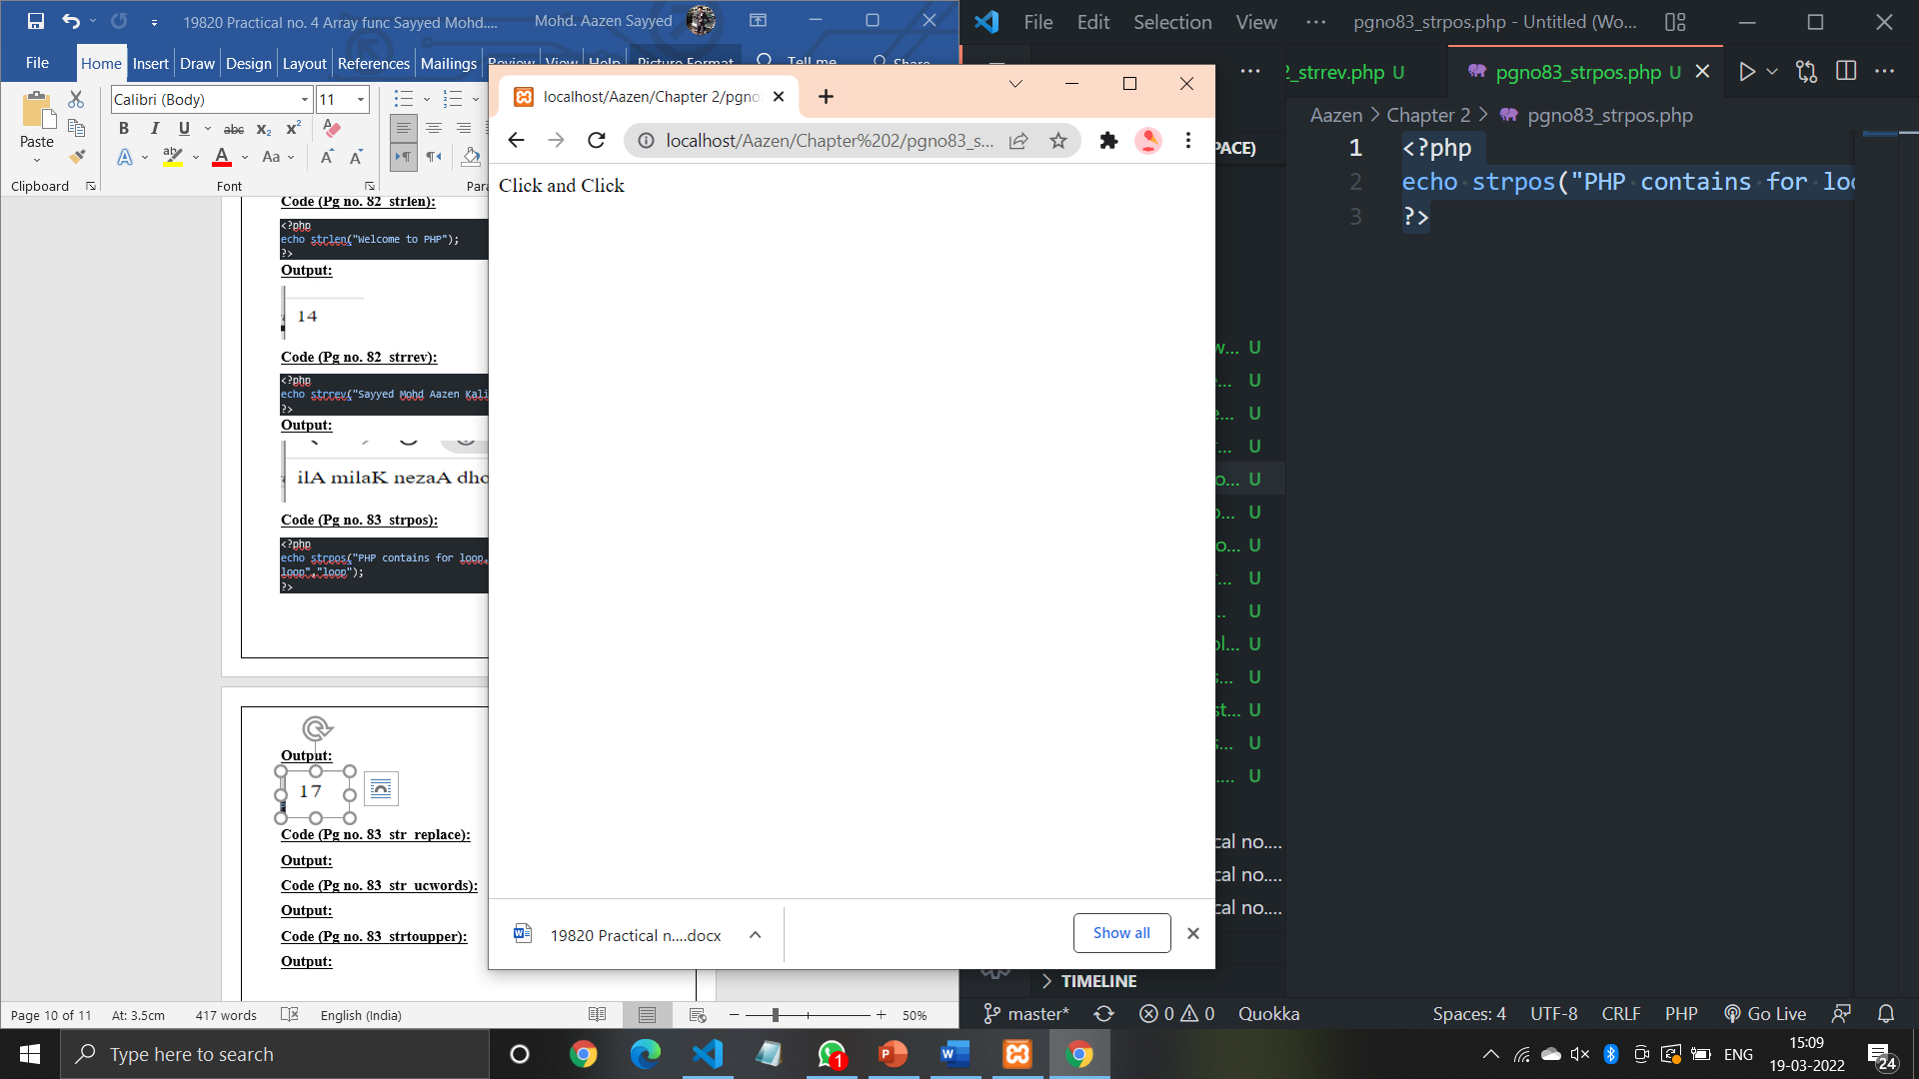

**Code (Pg no. 83_str_ucwords):**

<?php

echo ucwords("welcome to php world");

?>

**Output:**

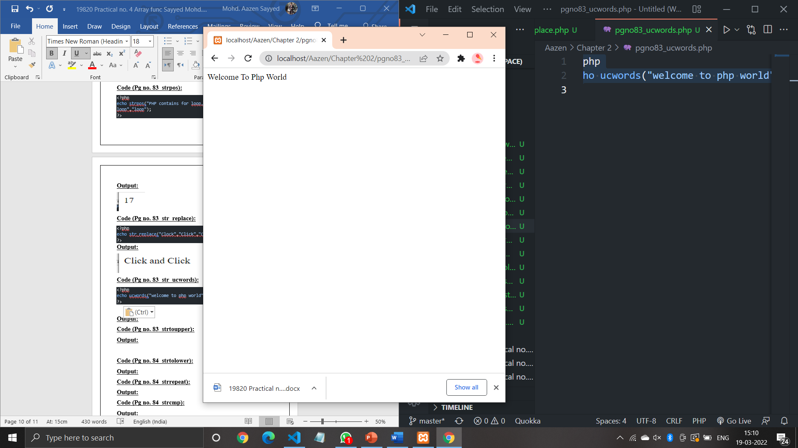

**Code (Pg no. 83_strtoupper):**

<?php

echo strtoupper("sayyed mohd aazen kalim ali");

?>

**Output:**

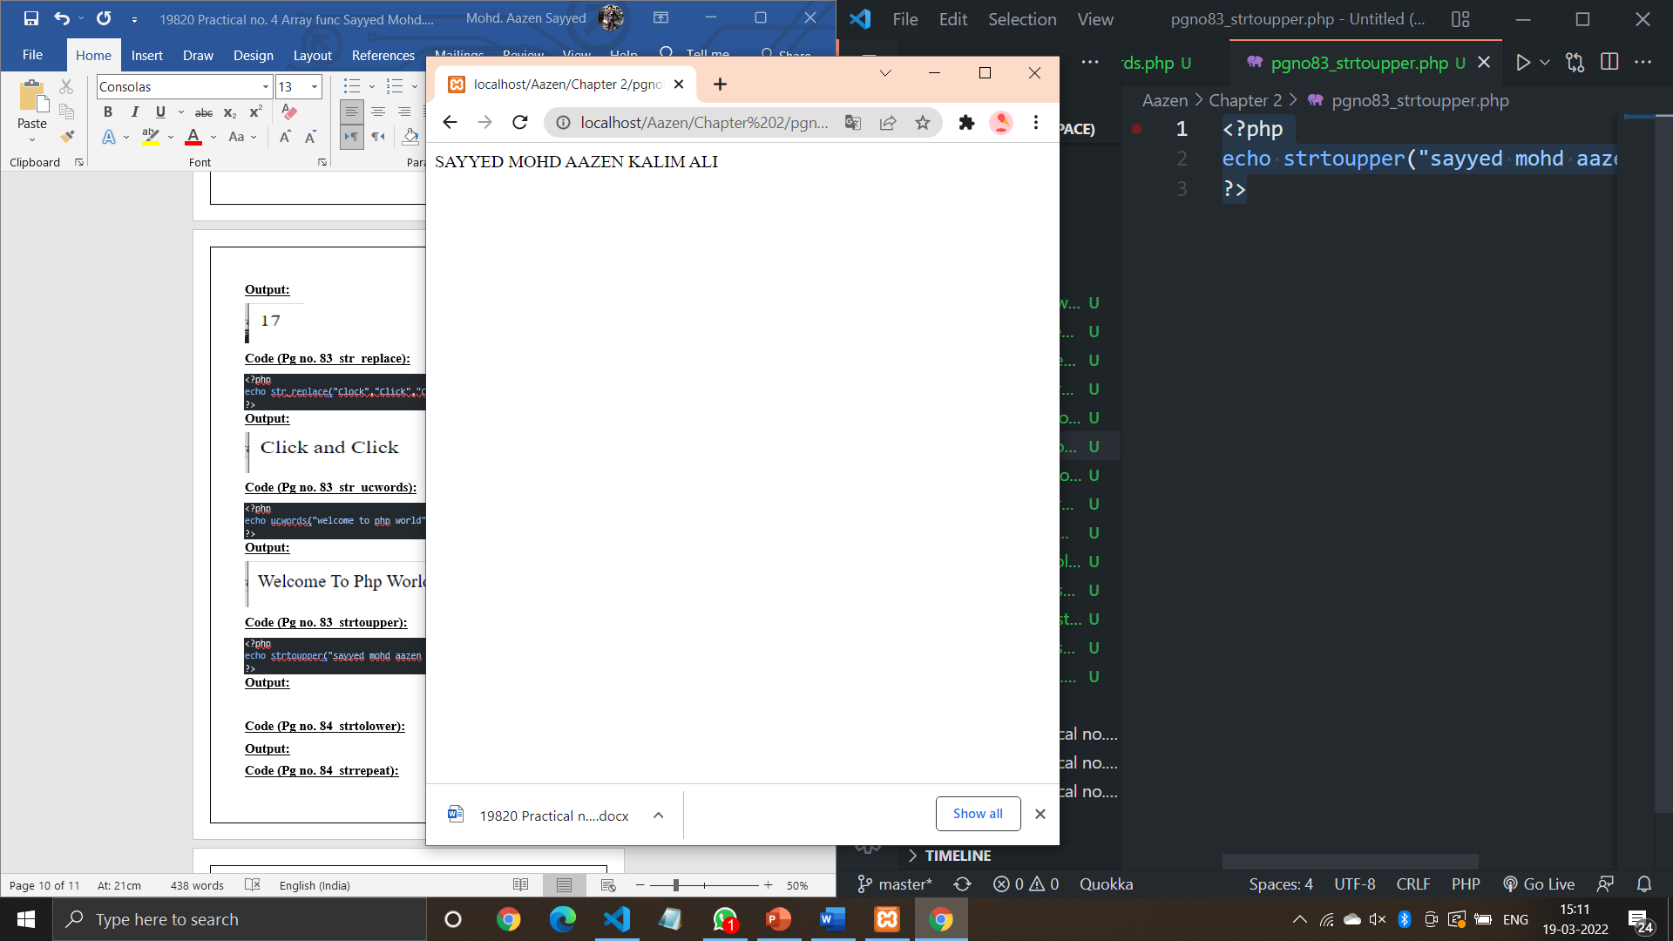

**Code (Pg no. 84_strtolower):**

<?php

echo strtolower("SAYYED MOHD AAZEN KALIM ALI");

?>

**Output:**

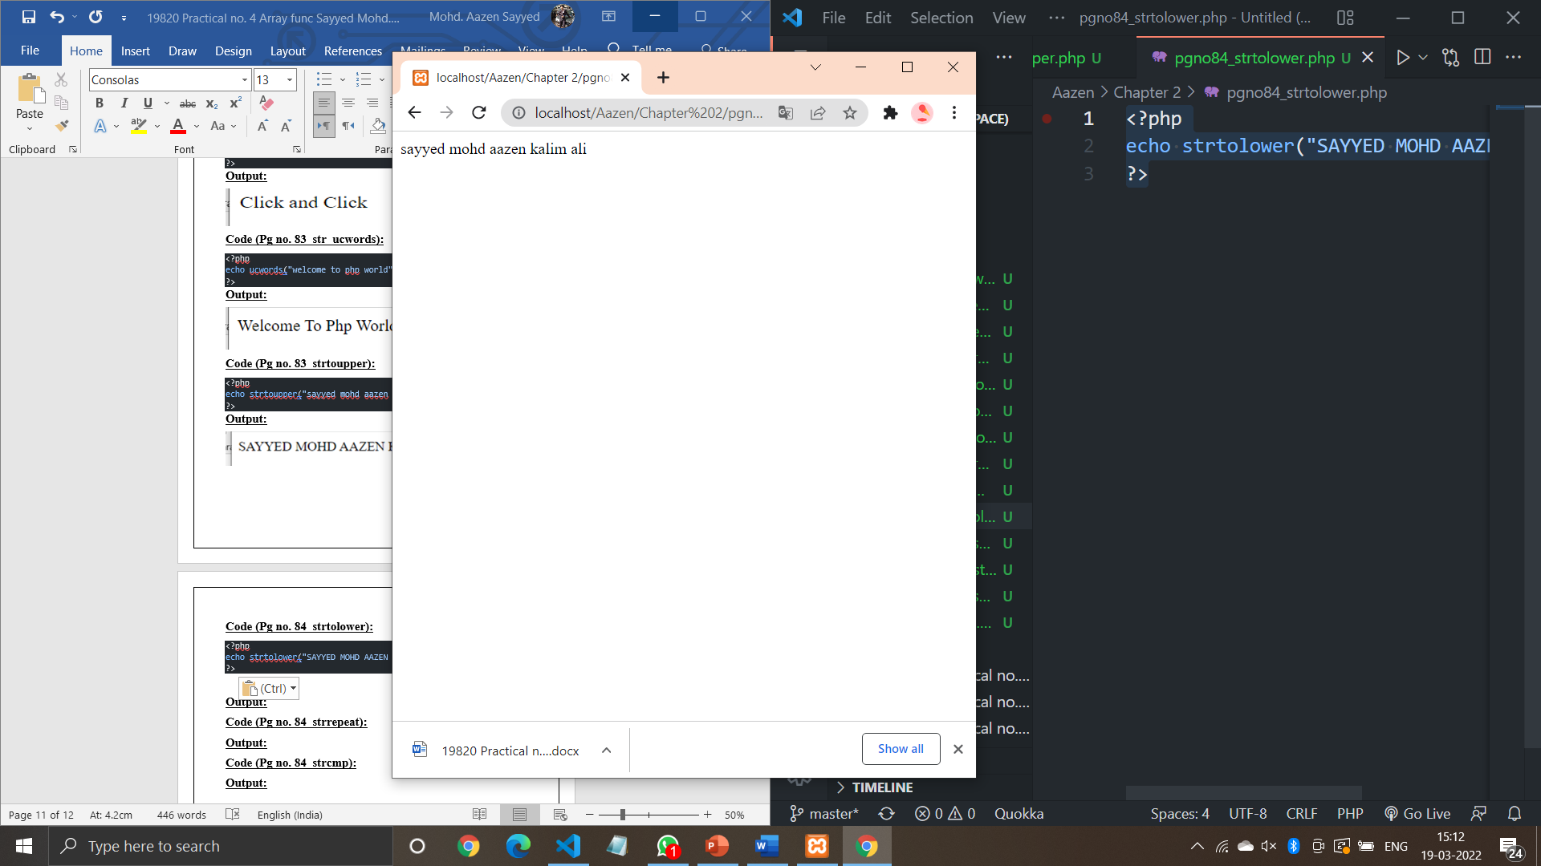

**Code (Pg no. 84_strrepeat):**

<?php

echo str_repeat("*",10);

?>

**Output:**

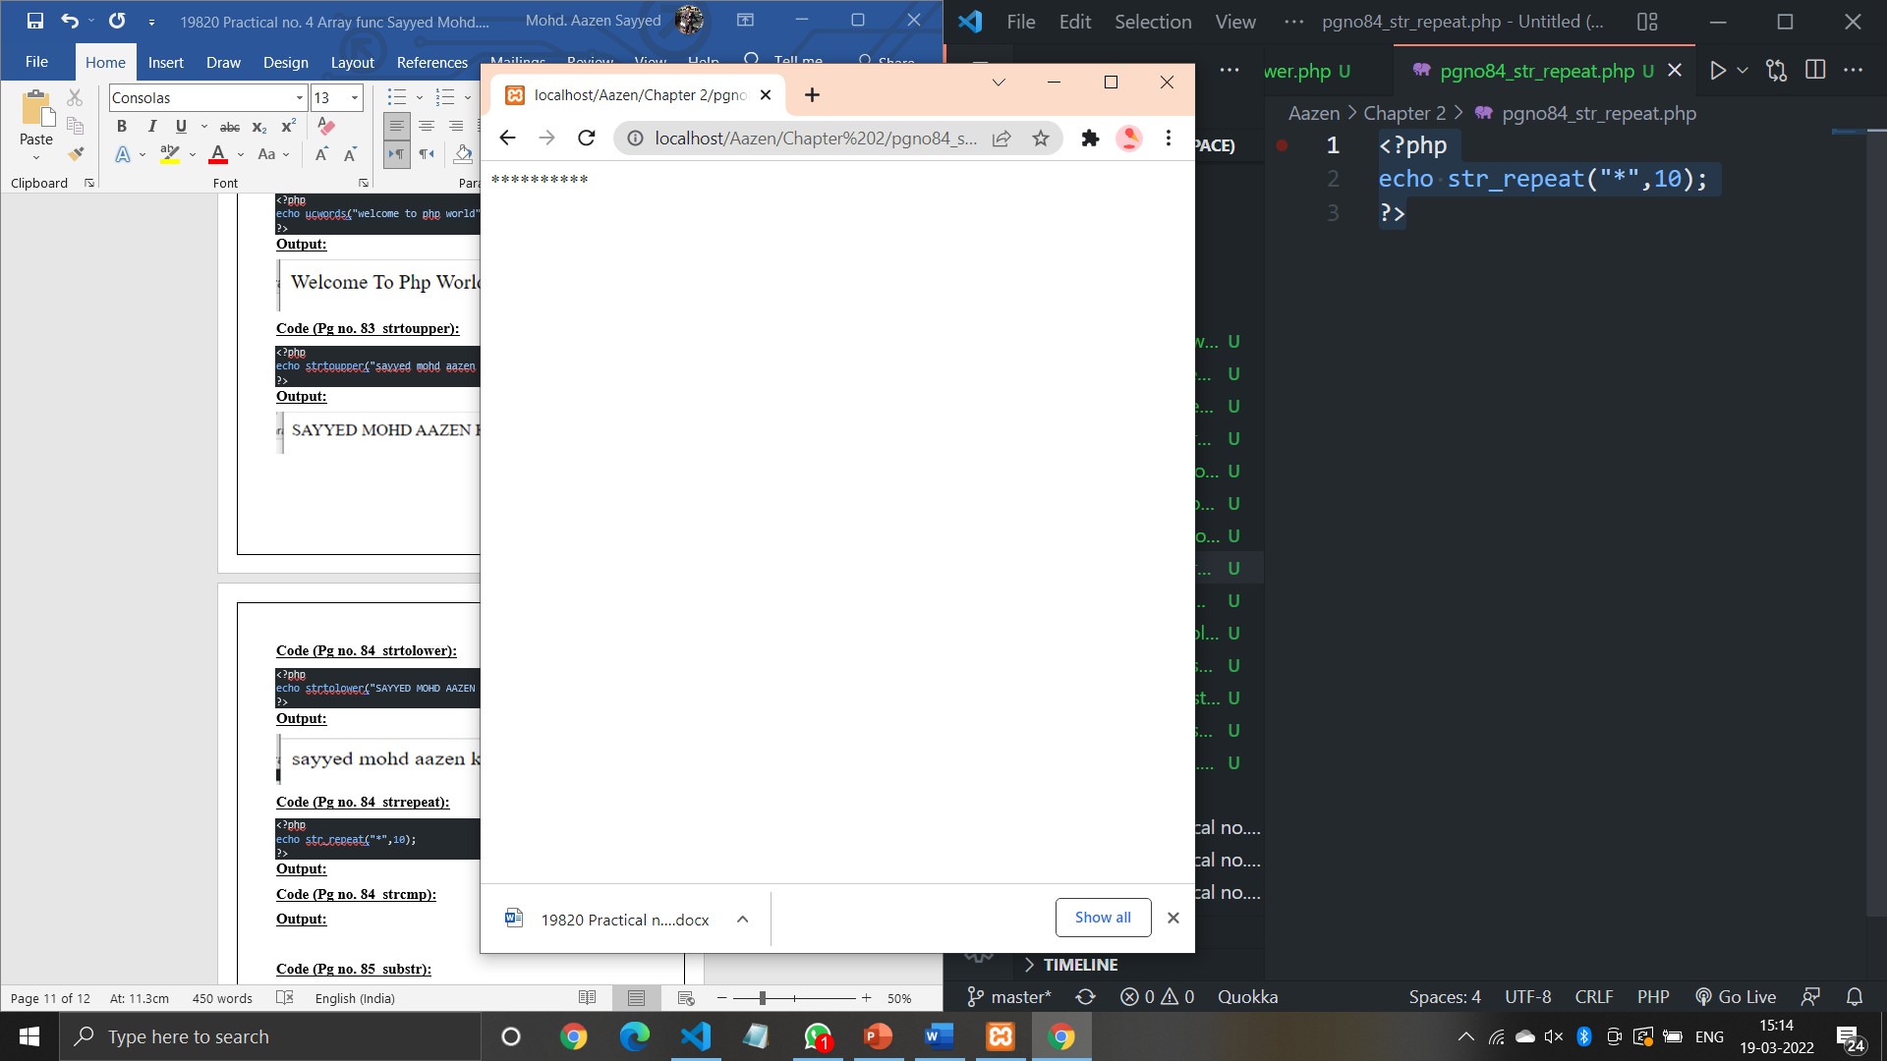

**Code (Pg no. 84_strcmp):**

<?php

echo strcmp("Hello world!","Hello world!");

echo strcmp("world!","Hello PHP!");

echo strcmp("Hello PHP!","world!");

?>

**Output:**

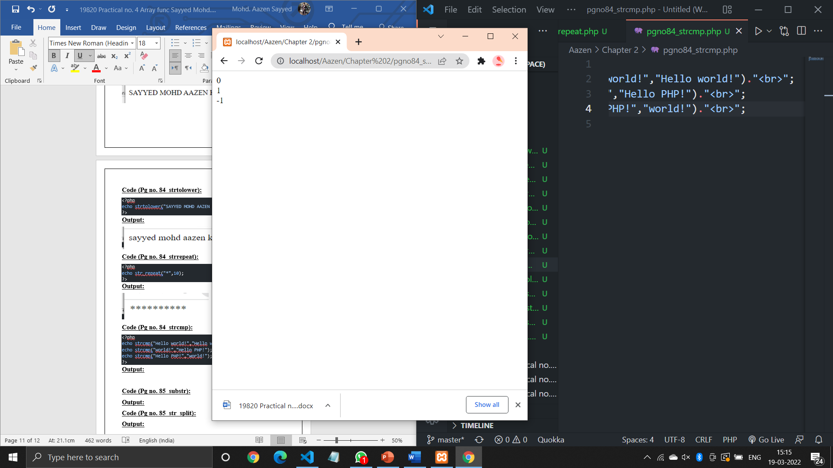

**Code (Pg no. 85_substr):**

<?php

echo substr("Welcome to PHP",11)."<br>";

echo substr("Welcome to PHP",0,7)."<br>";

?>

**Output:**

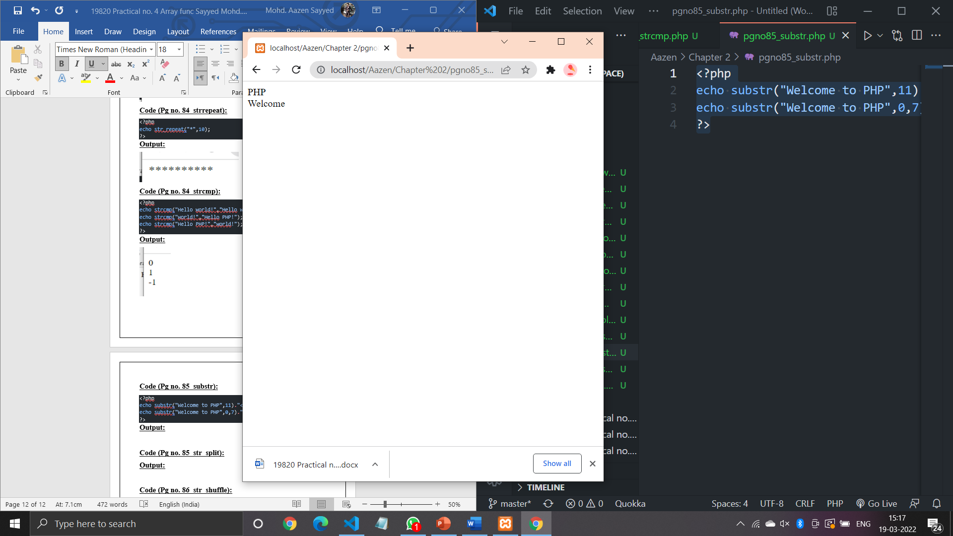

**Code (Pg no. 85_str_split):**

<?php

$str="PHP";

str_split($str);

?>

**Output:**

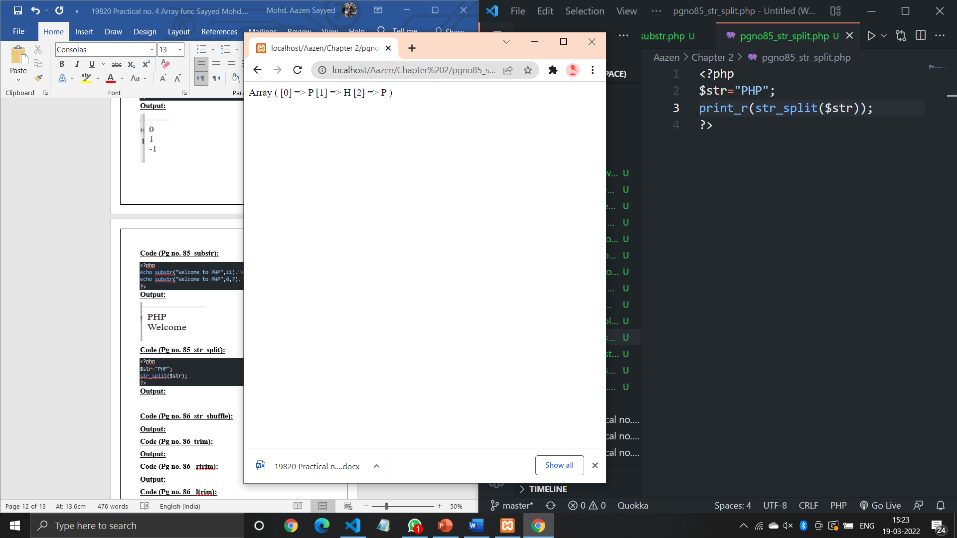

**Code (Pg no. 86_str_shuffle):**

<?php

$str="PHP";

print_r(str_shuffle($str));

?>

**Output:**

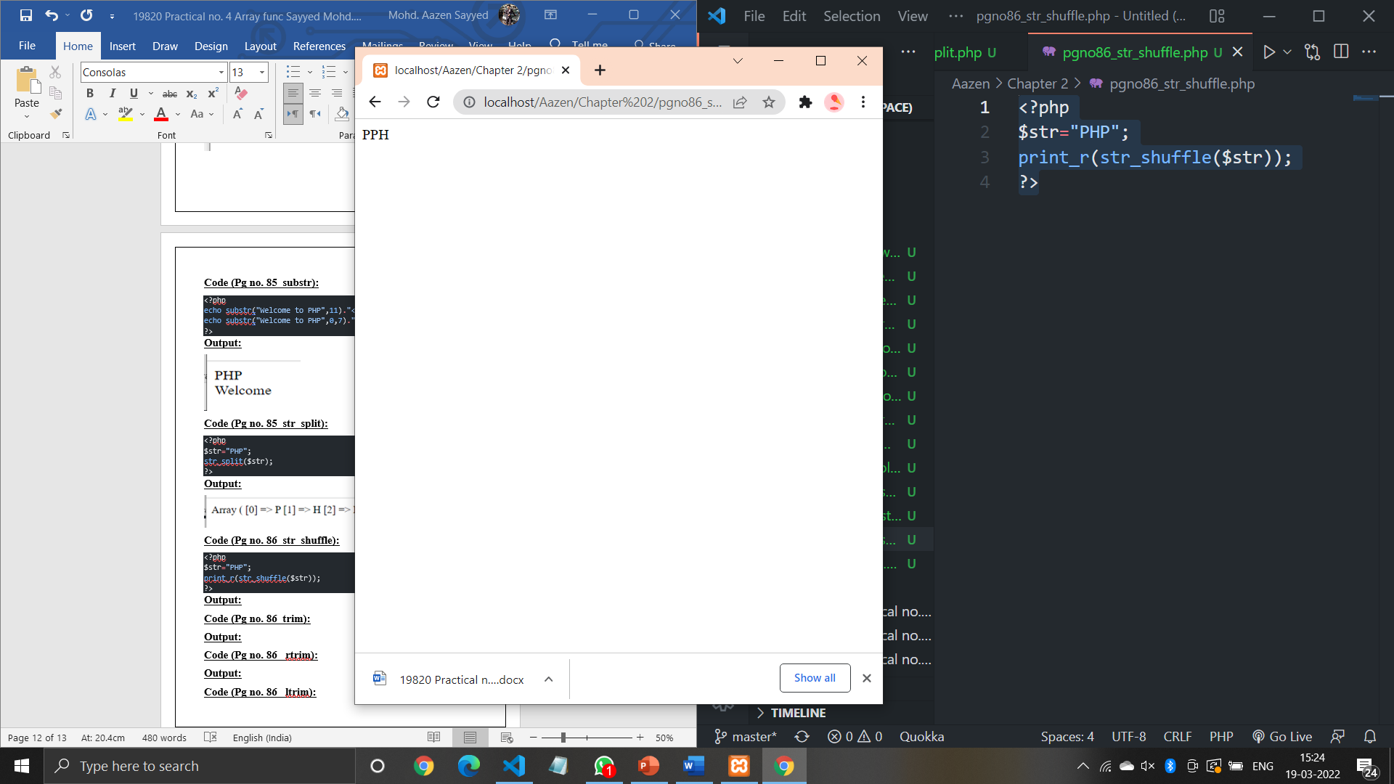

**Code (Pg no. 86_trim):**

<?php

$str="         Welcome";

echo(trim($str));

?>

**Output:**

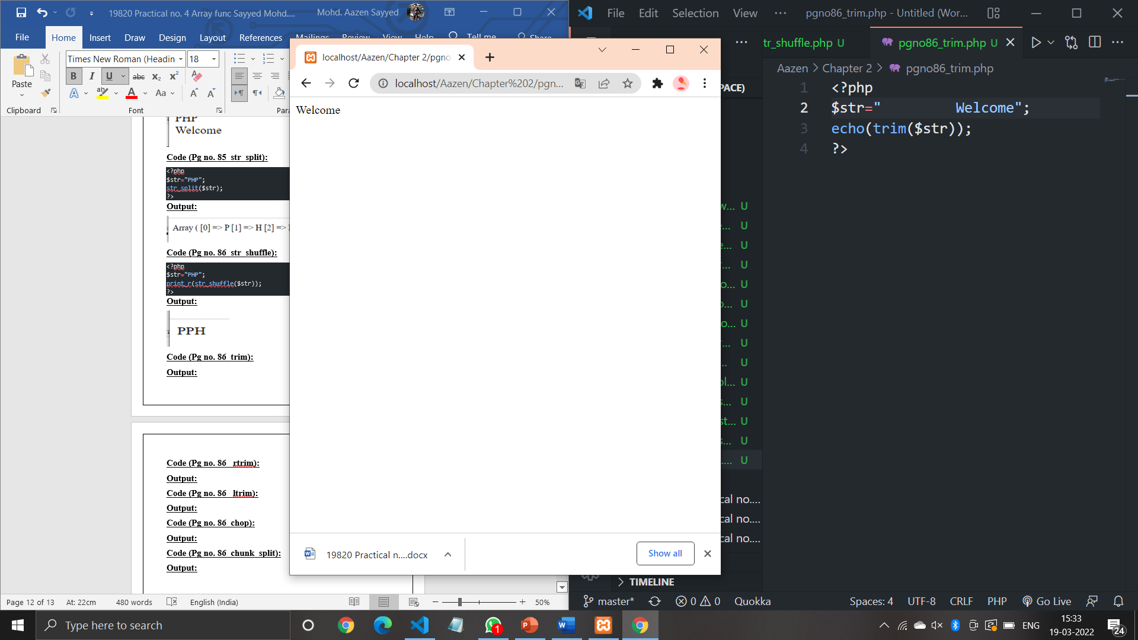

**Code (Pg no. 86_ rtrim):**

<?php

$str="Hello PHP";

print_r(rtrim($str,"PHP"));

?>

**Output:**

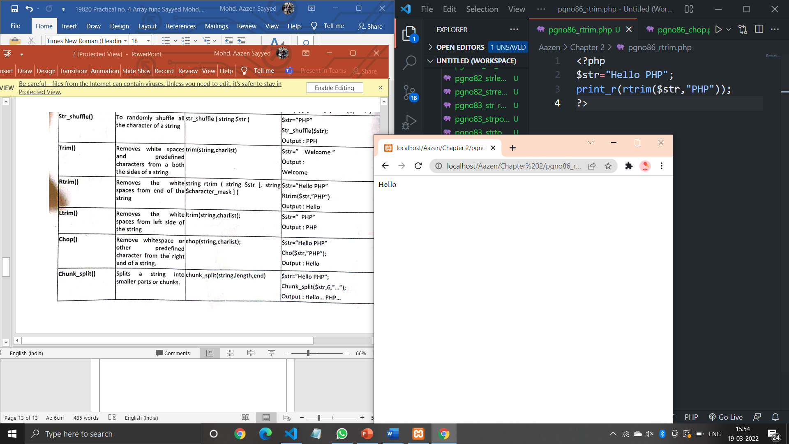

**Code (Pg no. 86_ ltrim):**

<?php

$str="Hello PHP";

print_r(ltrim($str,"Hello"));

?>

**Output:**

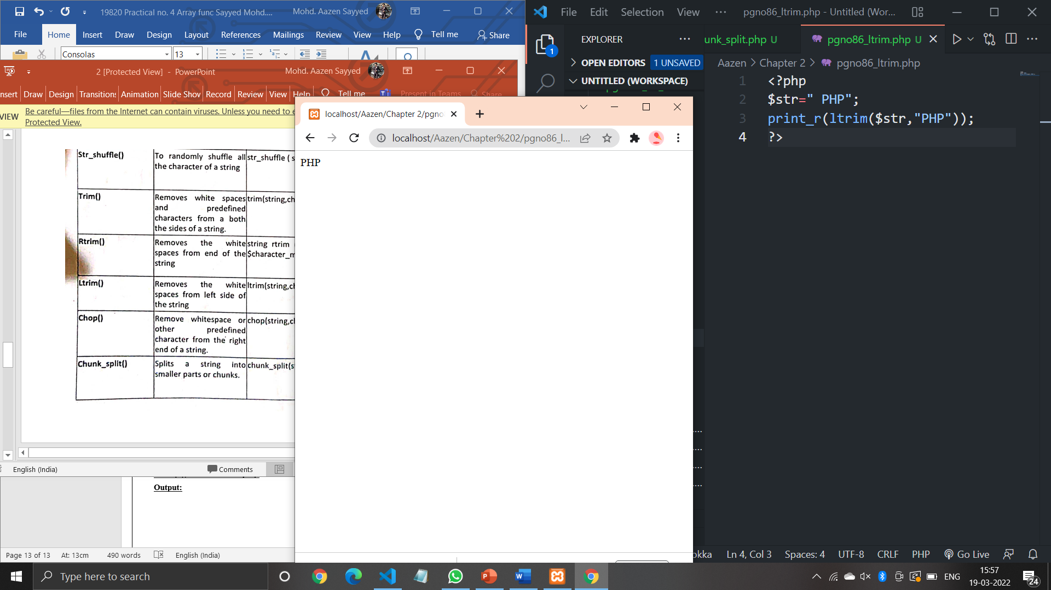

**Code (Pg no. 86_chop):**

<?php

$str="Hello PHP";

print_r(chop($str,"PHP"));

?>

**Output:**

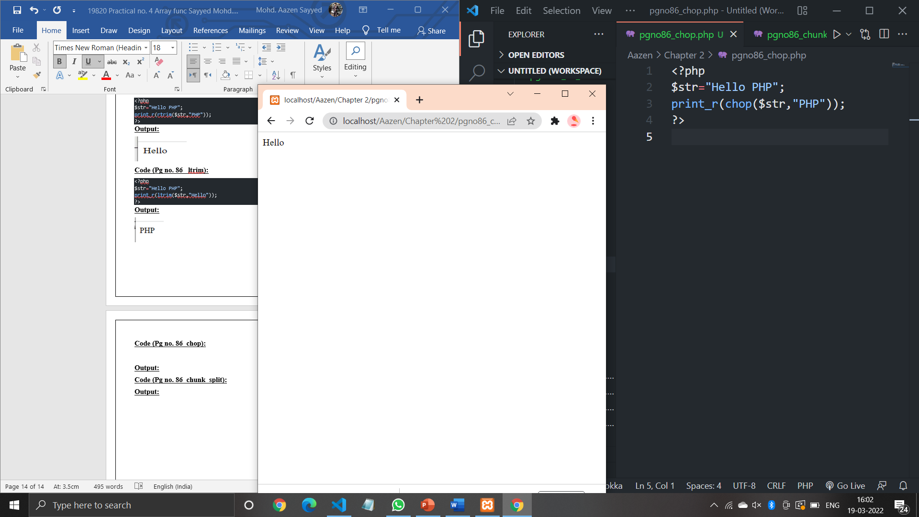

**Code (Pg no. 86_chunk_split):**

<?php

$str="Hello PHP";

print_r(chunk_split($str,6,"..."));

?>

**Output:**

